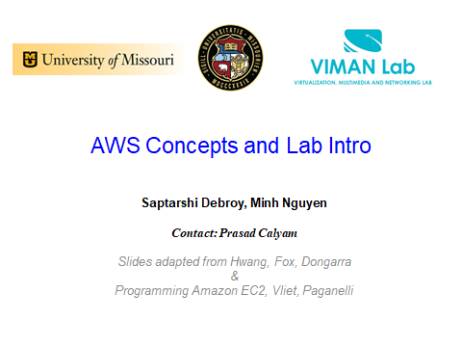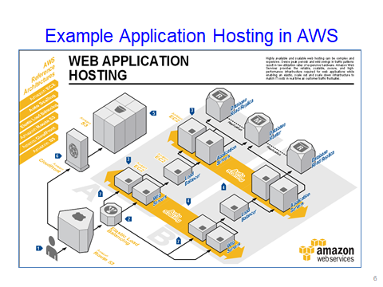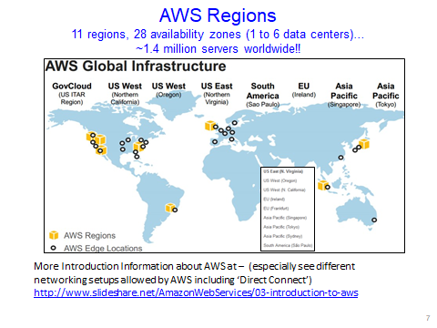

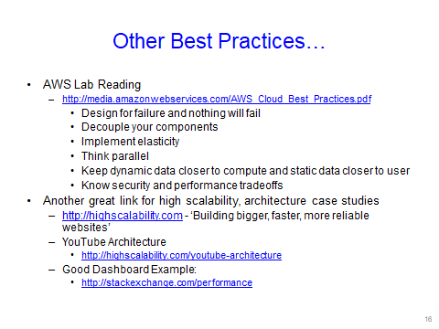

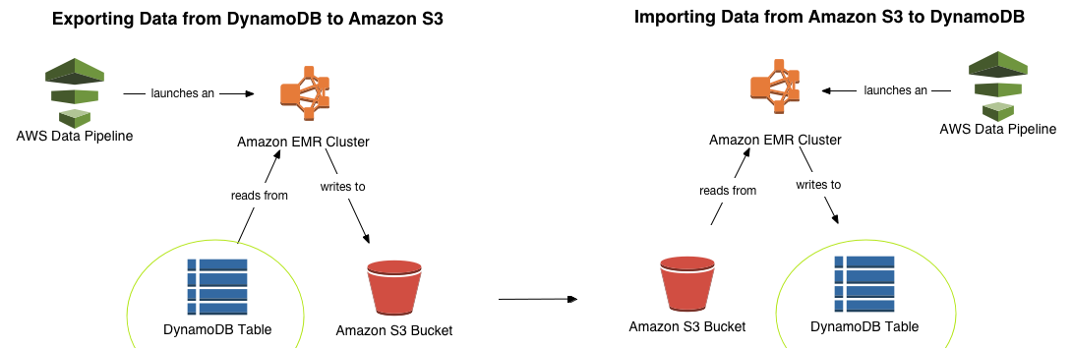

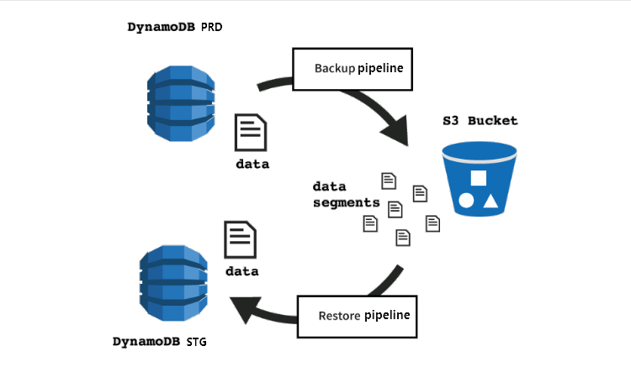

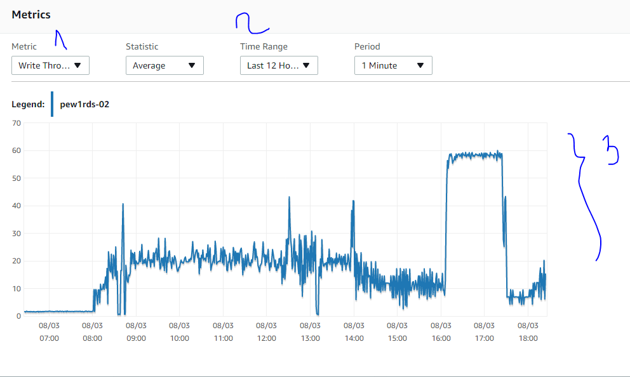

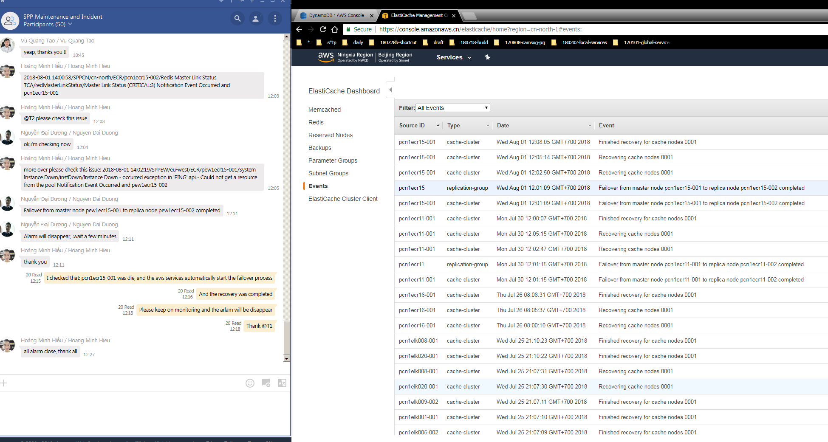

#------------------------------

#------------------------------

#------------------------------

#------------------------------

#------------------------------

#------------------------------

#---------------------------------------------------

#---------------------------------------------------

#---------------------------------------------------

Mastering NGINX

Dimitri Aivaliotis

www.it-ebooks.info

sudo apt-get install nginx

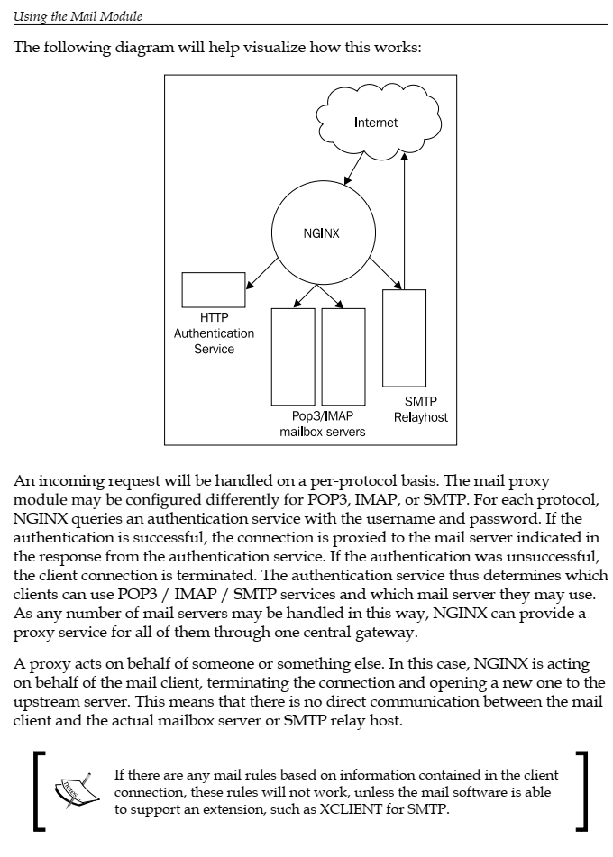

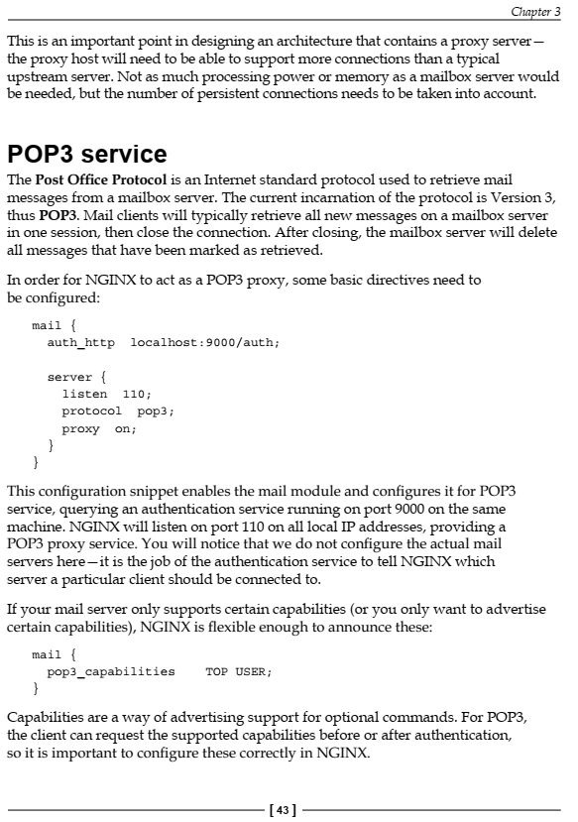

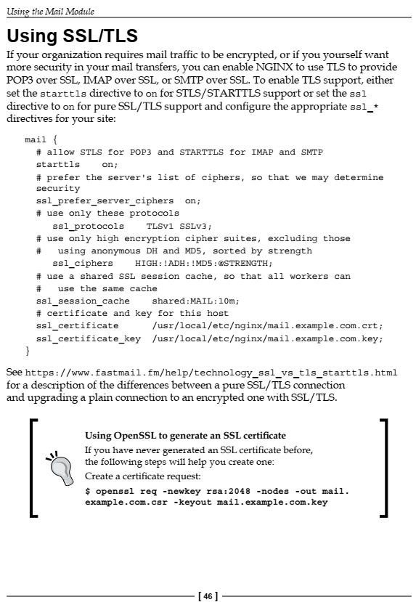

#---------------------------------------------------

#---------------------------------------------------

Authentication service

We have mentioned the authentication service quite a few times in the previous

section, but what exactly is the authentication service and what does it do? When

a user makes a POP3, IMAP, or SMTP request to NGINX, authenticating the

connection is one of the frst steps. NGINX does not perform this authentication

itself, but rather makes a query to an authentication service that will fulfll the

request. NGINX then uses the response from the authentication service to make

the connection to the upstream mail server.

This authentication service may be written in any language. It need only conform

to the authentication protocol required by NGINX. The protocol is similar to HTTP,

so it will be fairly easy for us to write our own authentication service.

NGINX will send the following headers in its request to the authentication service:

• Host

• Auth-Method

• Auth-User

• Auth-Pass

• Auth-Salt

• Auth-Protocol

• Auth-Login-Attempt

• Client-IP

• Client-Host

#---------------------------------------------------

#---------------------------------------------------

Authentication service

We have mentioned the authentication service quite a few times in the previous

section, but what exactly is the authentication service and what does it do? When

a user makes a POP3, IMAP, or SMTP request to NGINX, authenticating the

connection is one of the frst steps. NGINX does not perform this authentication

itself, but rather makes a query to an authentication service that will fulfll the

request. NGINX then uses the response from the authentication service to make

the connection to the upstream mail server.

This authentication service may be written in any language. It need only conform

to the authentication protocol required by NGINX. The protocol is similar to HTTP,

so it will be fairly easy for us to write our own authentication service.

NGINX will send the following headers in its request to the authentication service:

• Host

• Auth-Method

• Auth-User

• Auth-Pass

• Auth-Salt

• Auth-Protocol

• Auth-Login-Attempt

• Client-IP

• Client-Host

#---------------------------------------------------

#---------------------------------------------------

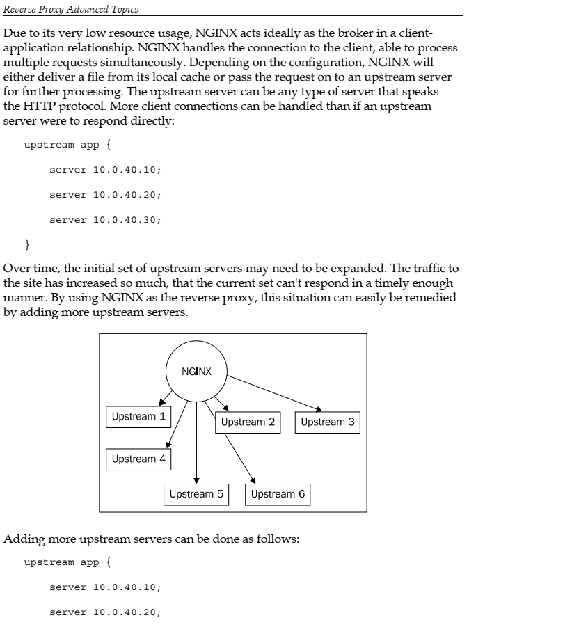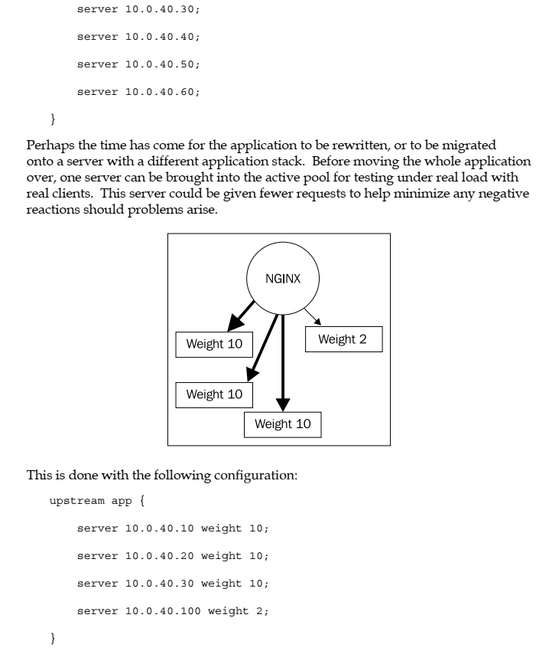

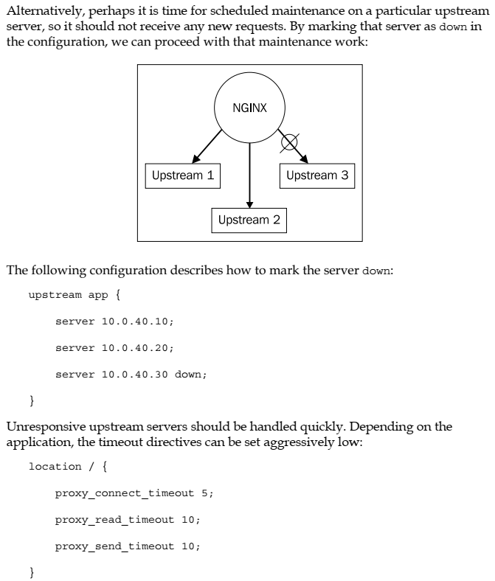

Mastering NGINX

Copyright © 2013 Packt Publishing

ISBN 978-1-84951-744-7

www.packtpub.com

#---------------------------------------------------

#---------------------------------------------------

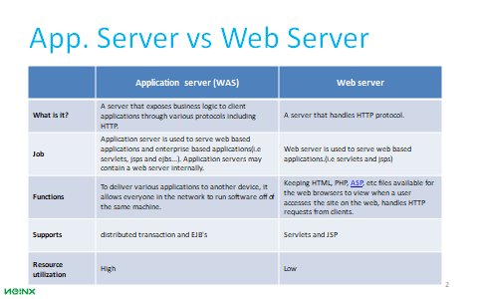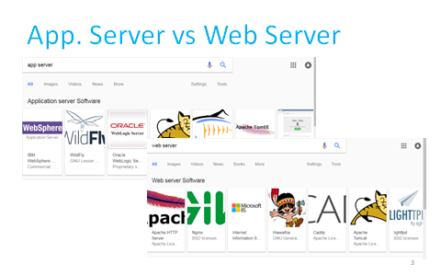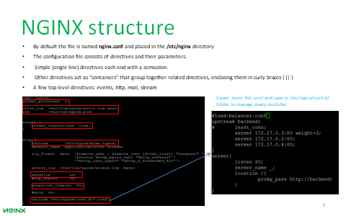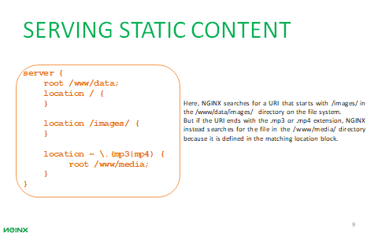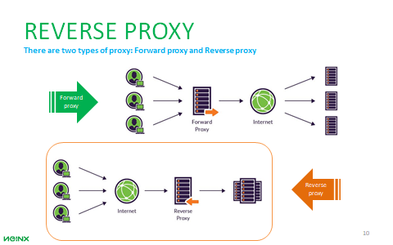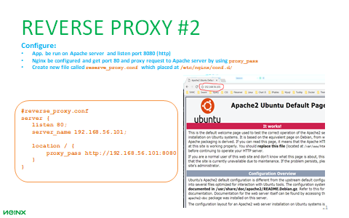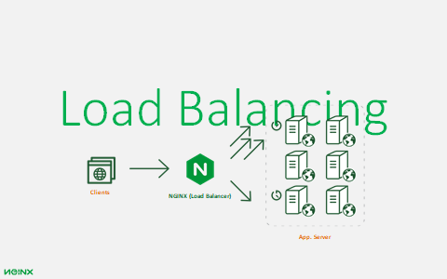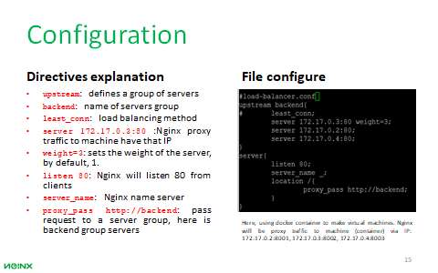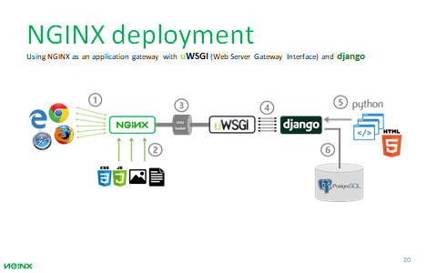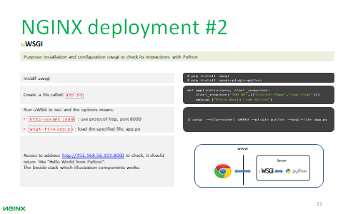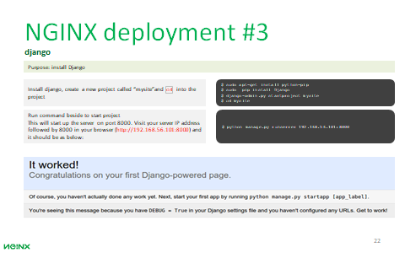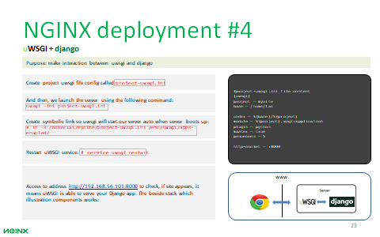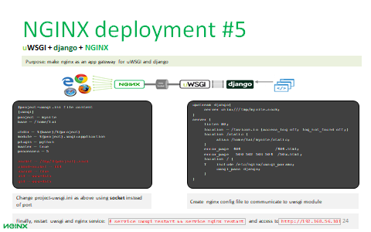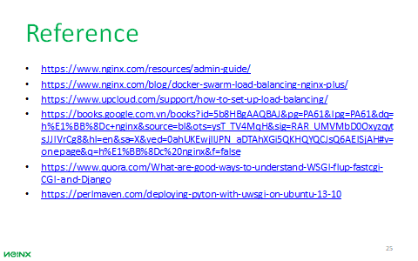

#---------------------------------------------------

#---------------------------------------------------

wget http://www-eu.apache.org/dist/cassandra/3.10/apache-cassandra-3.10-bin.tar.gz

wget http://download.oracle.com/otn-pub/java/jdk/8u131-b11/d54c1d3a095b4ff2b6607d096fa80163/jdk-8u131-linux-x64.tar.gz?AuthParam=1494413635_f7bfe295a1b8187c8b8f2d0b0132d461

wget https://www.python.org/ftp/python/3.6.1/Python-3.6.1.tgz

-number token:

scloud@10-42-53-22:/home/cass/data$ --> mount to physic

#---------------------------------------------------

#---------------------------------------------------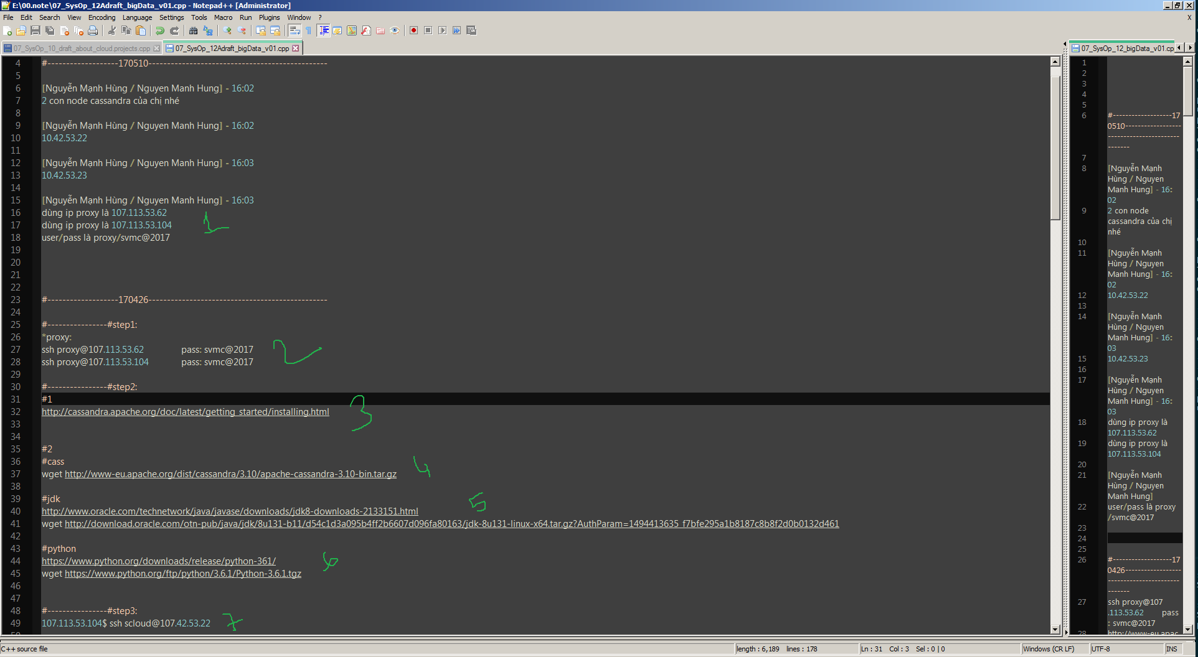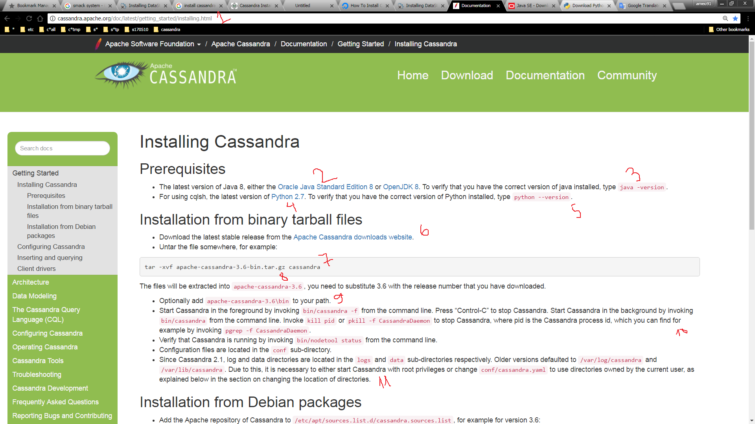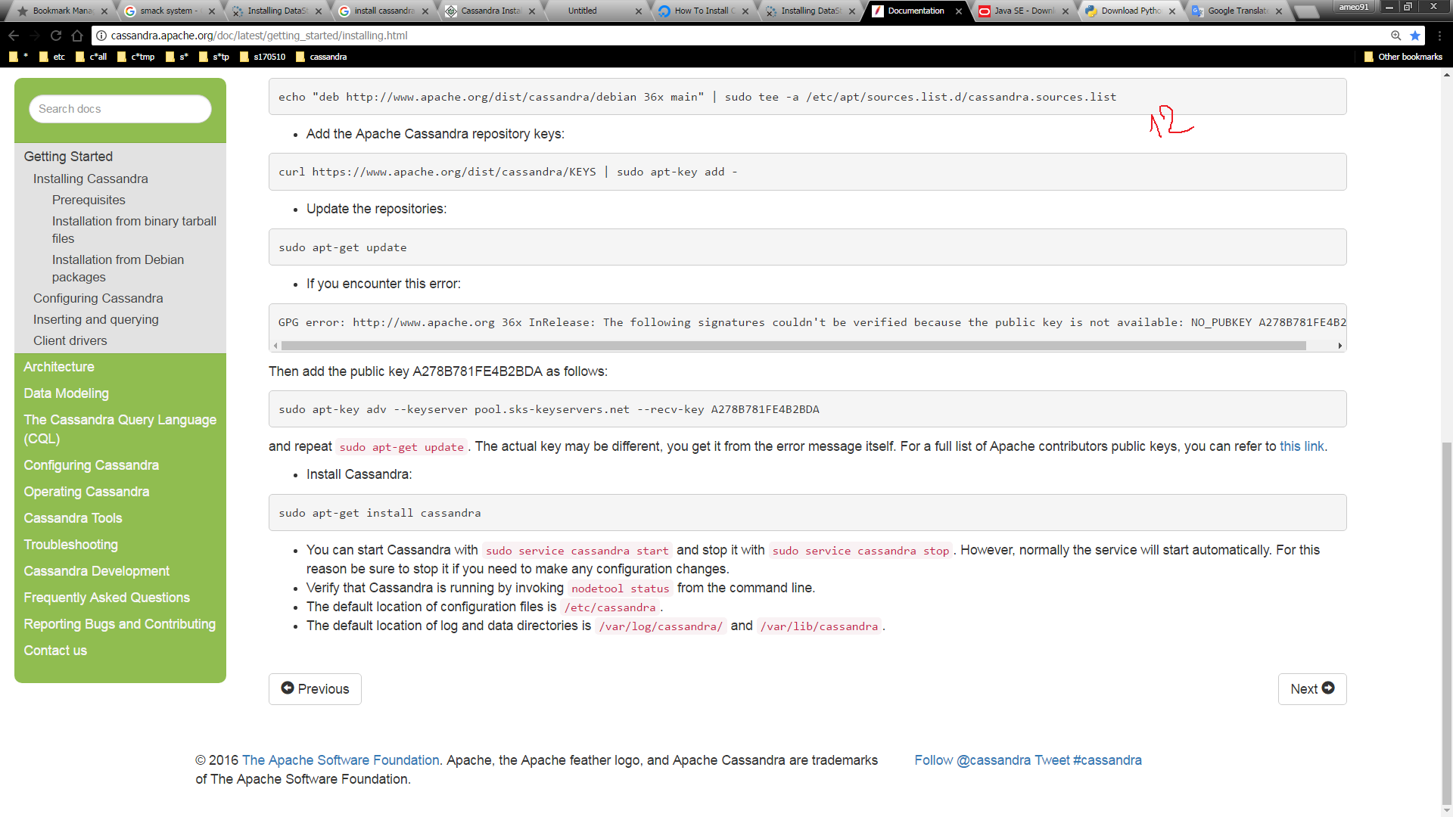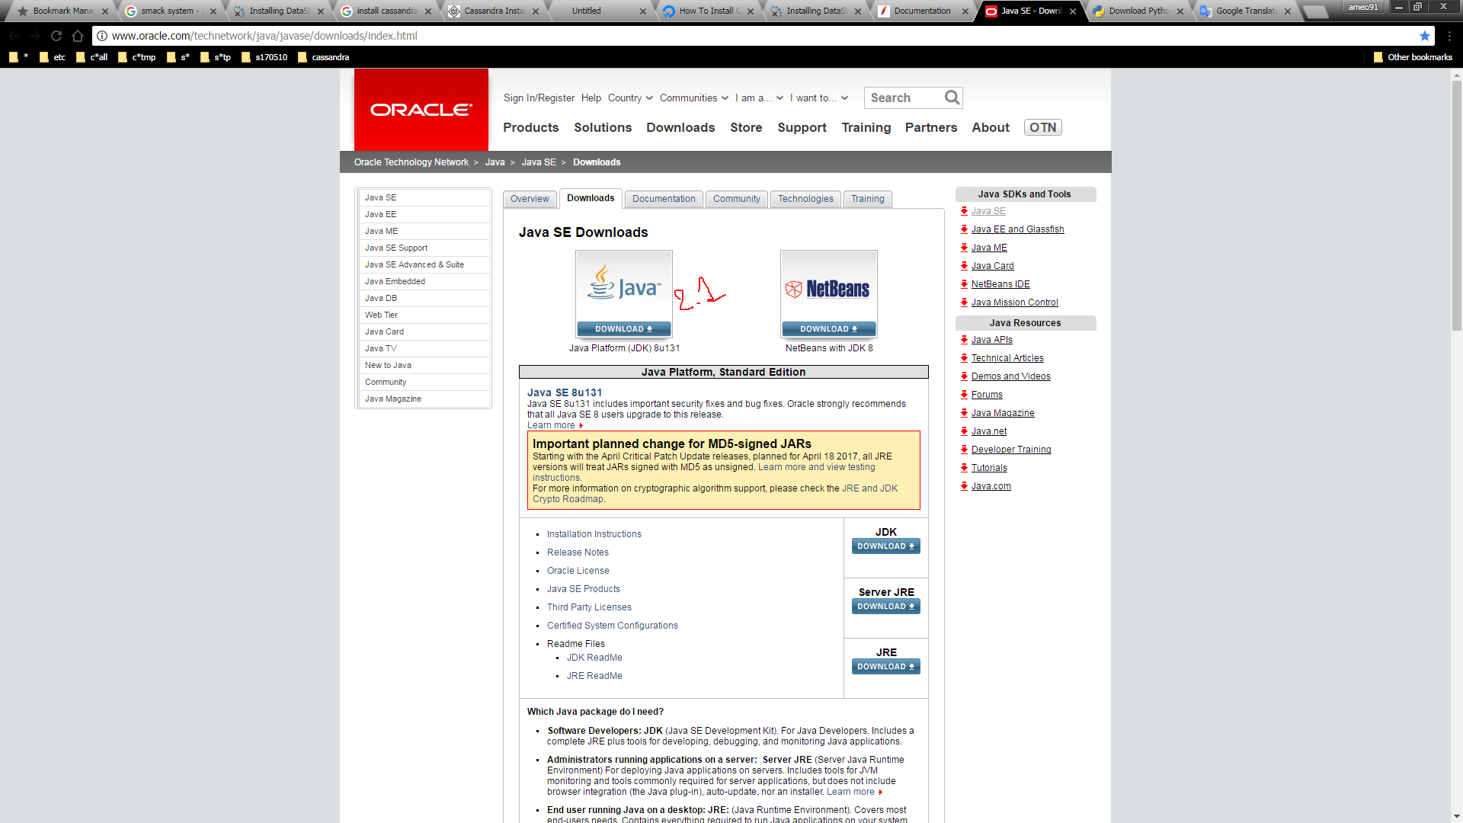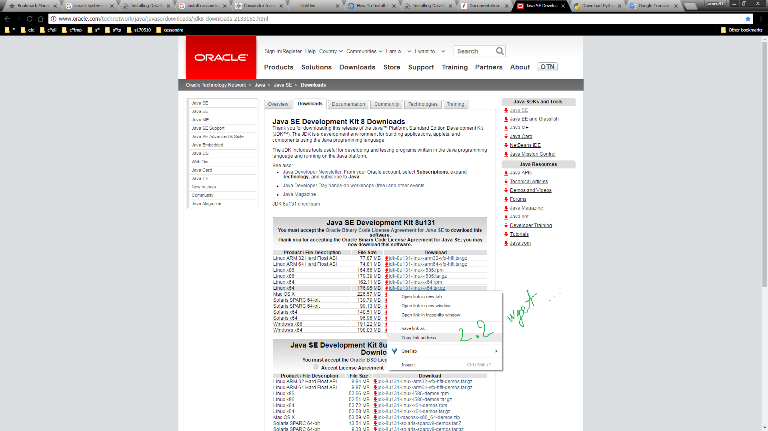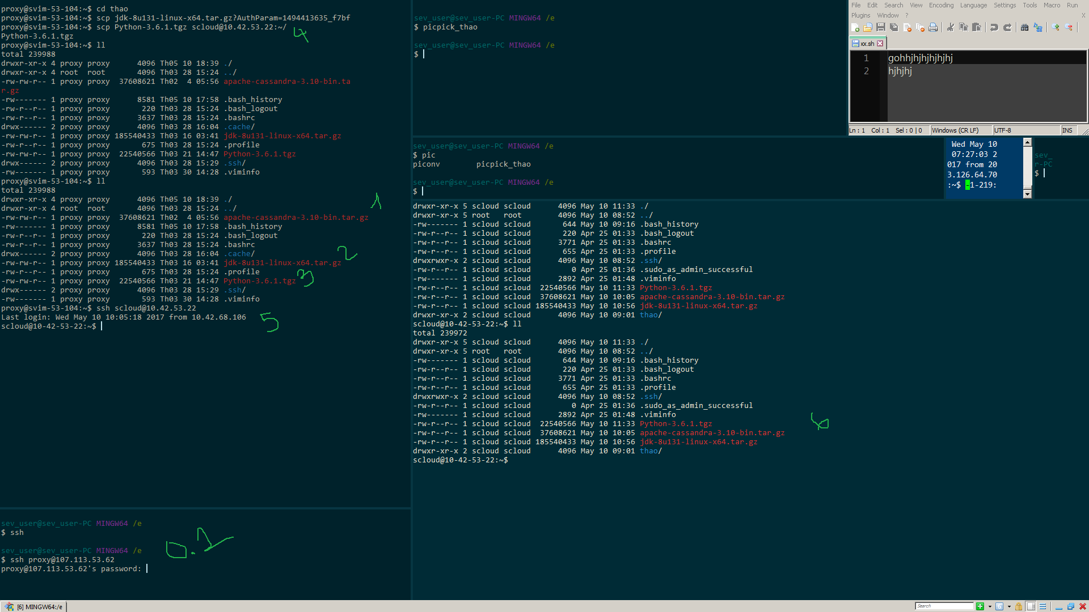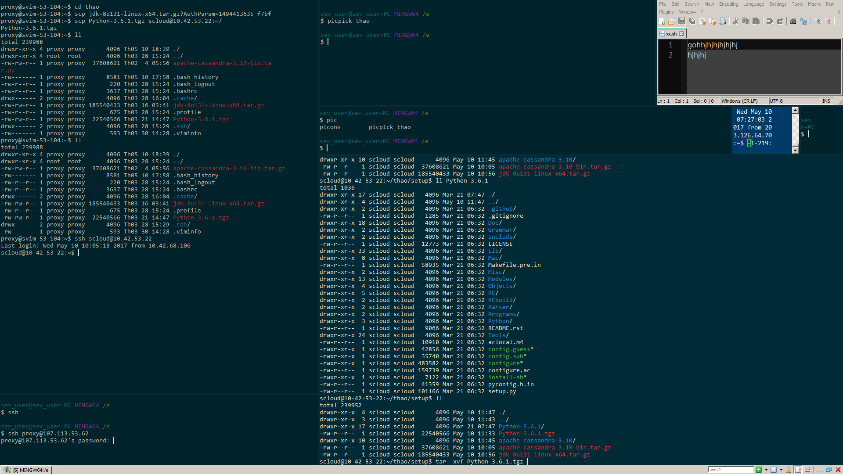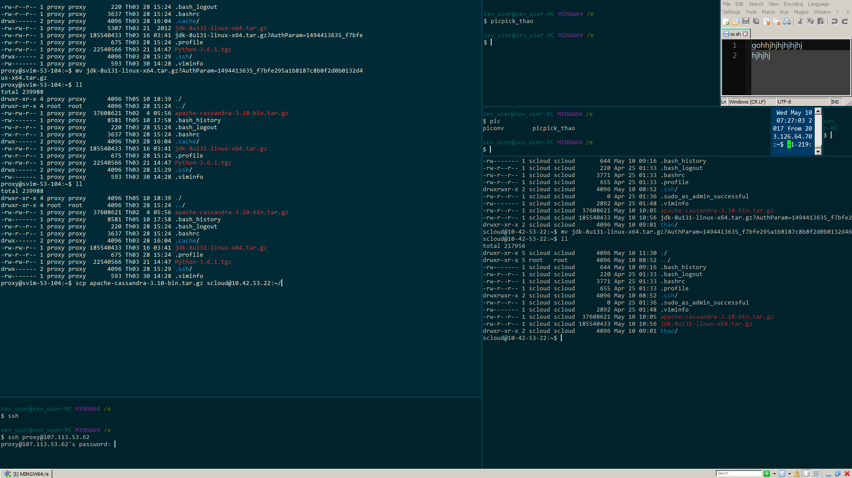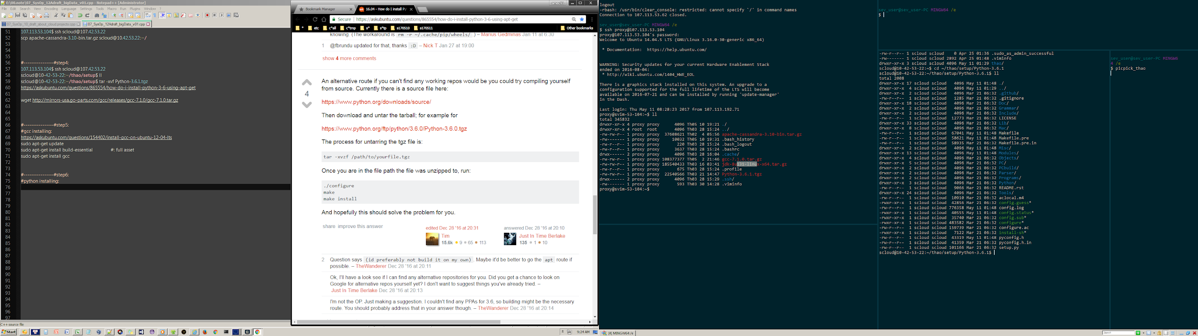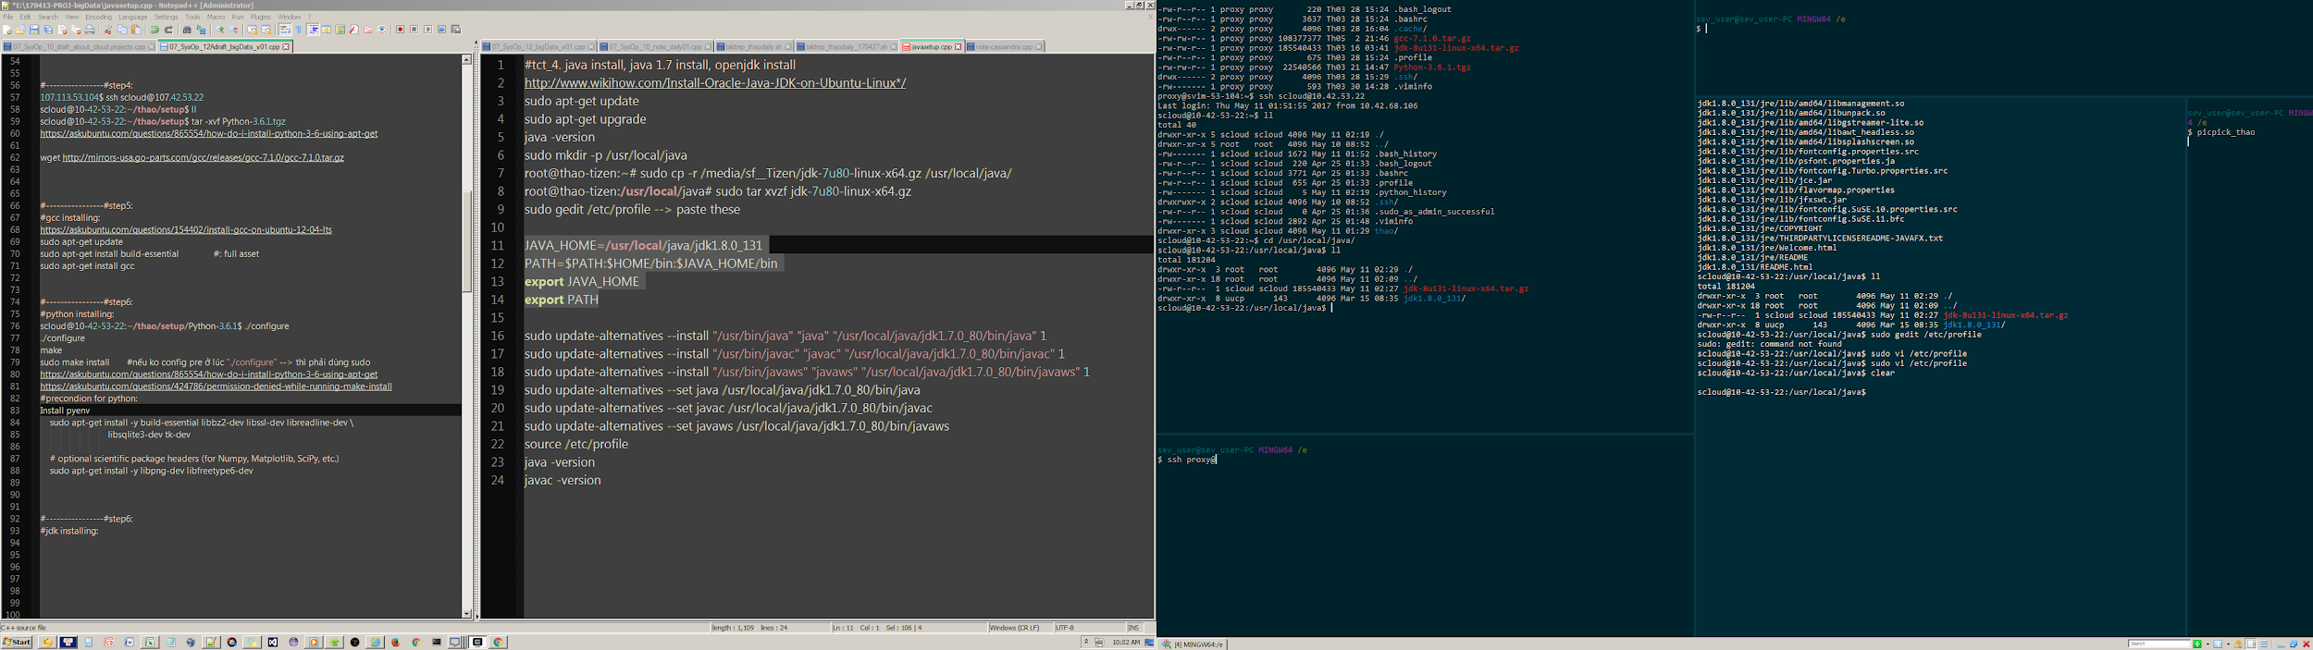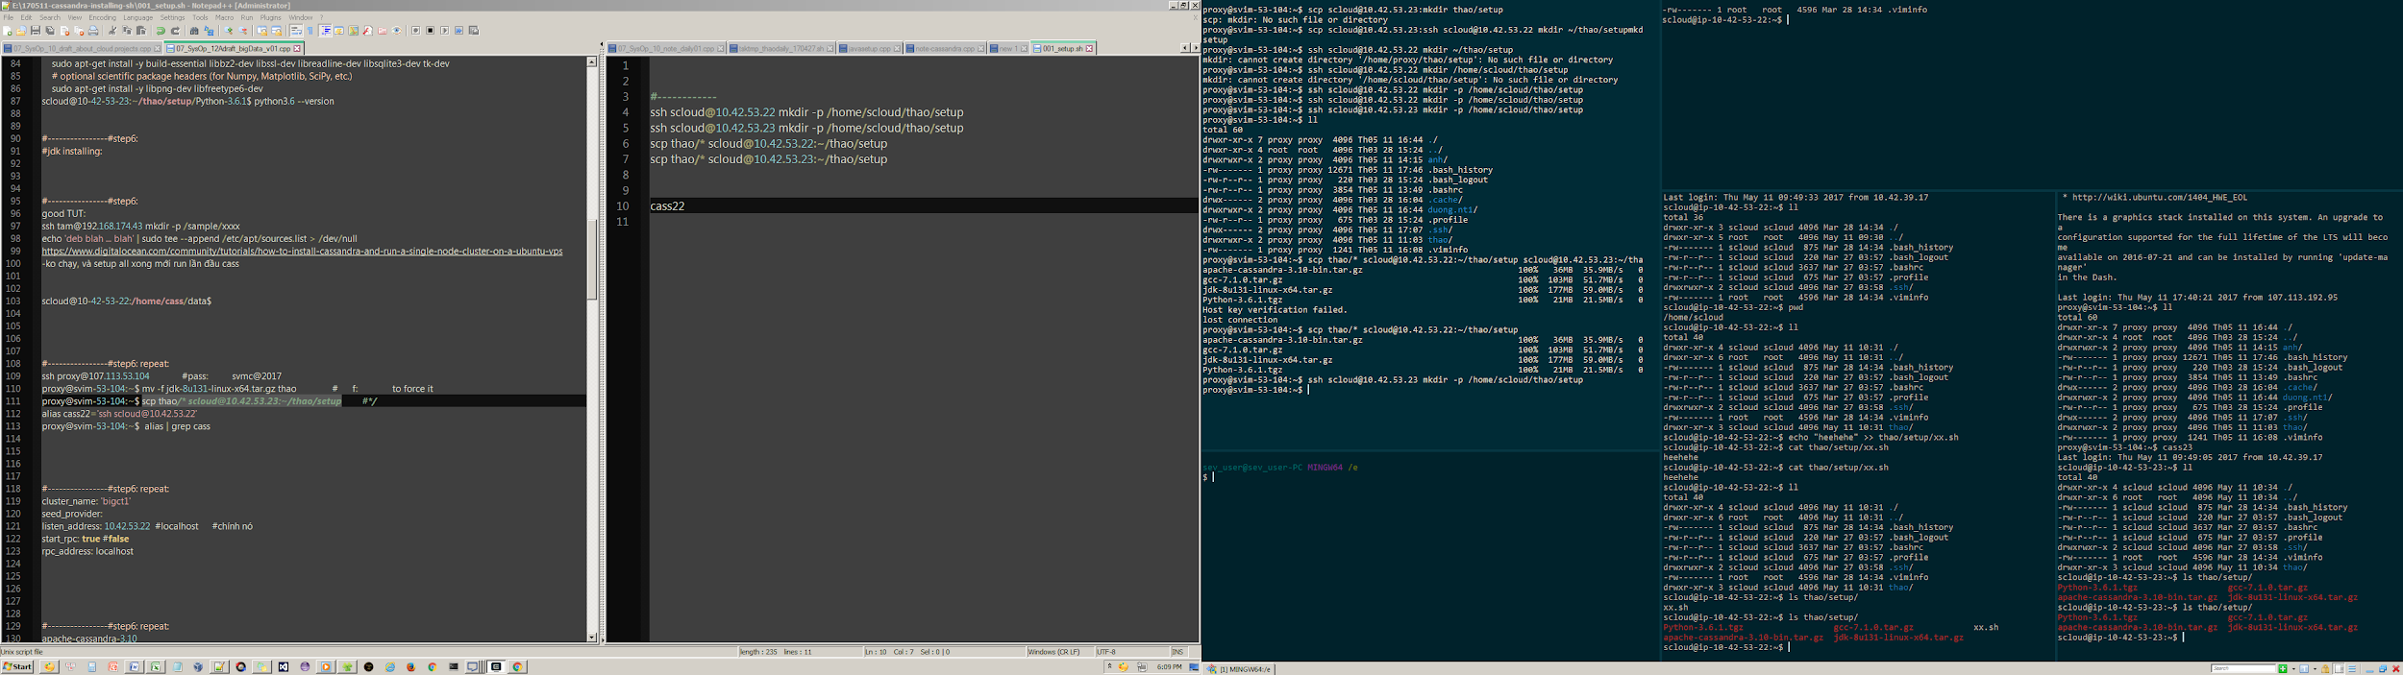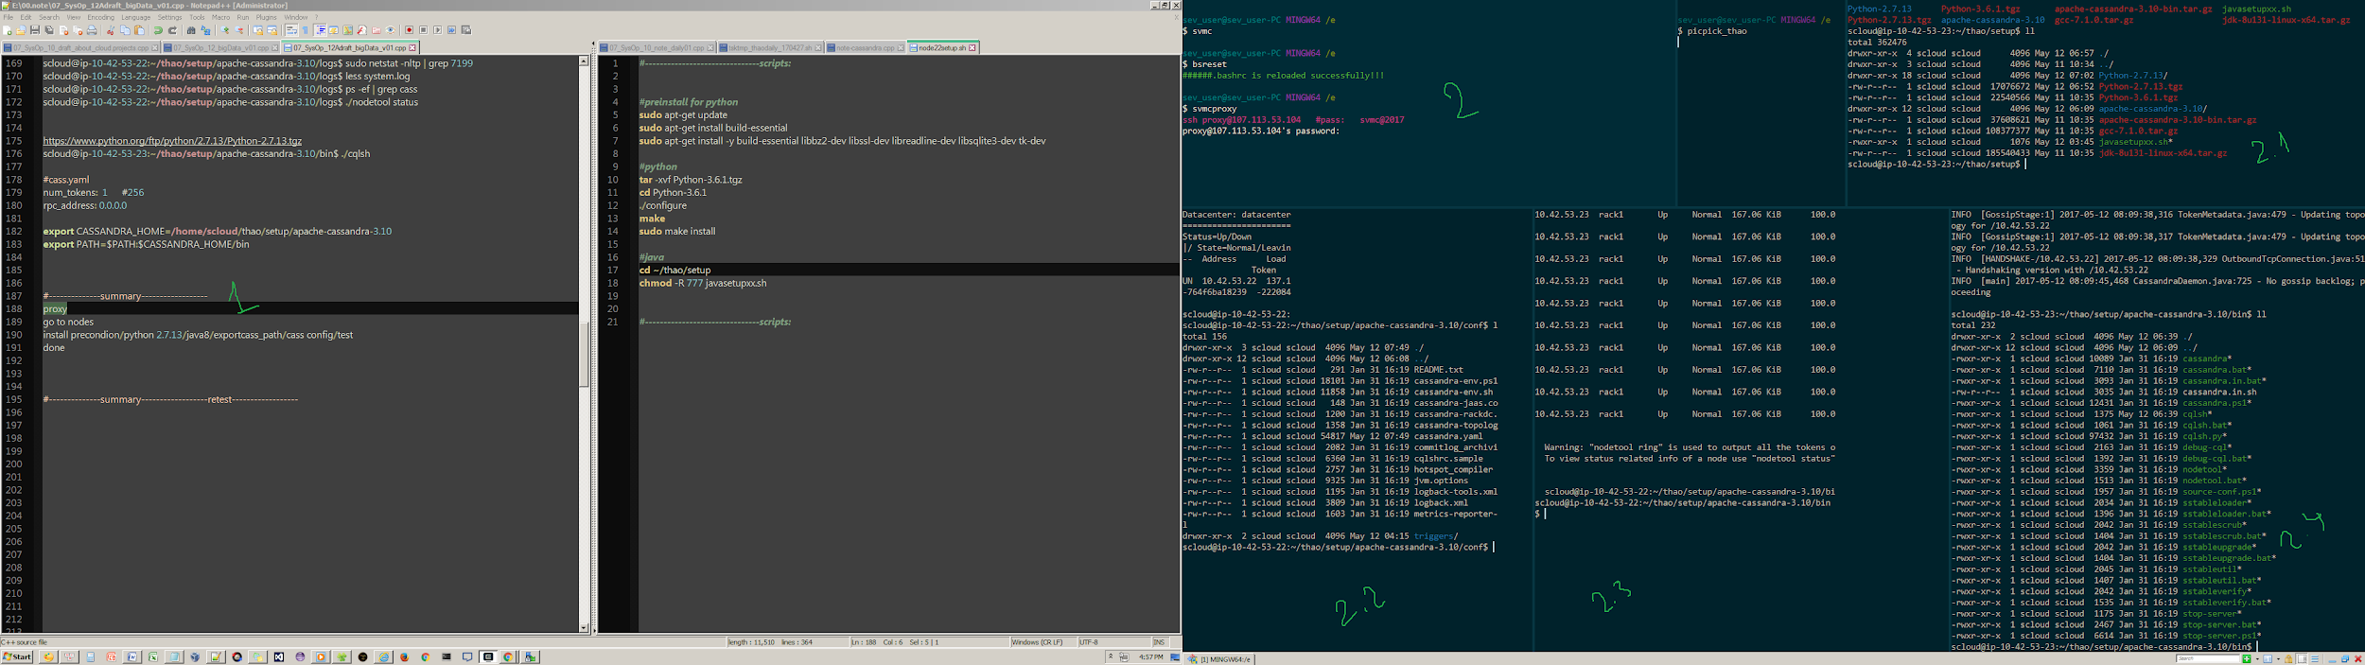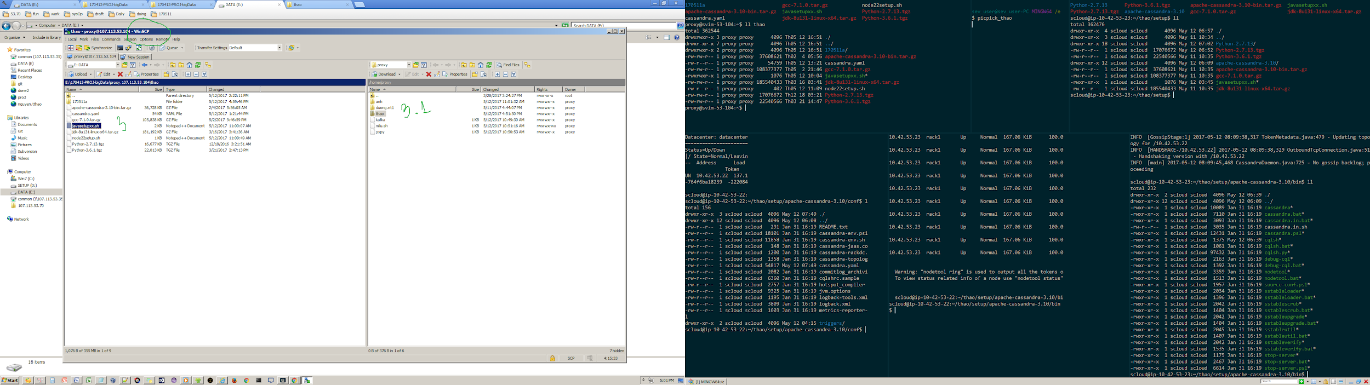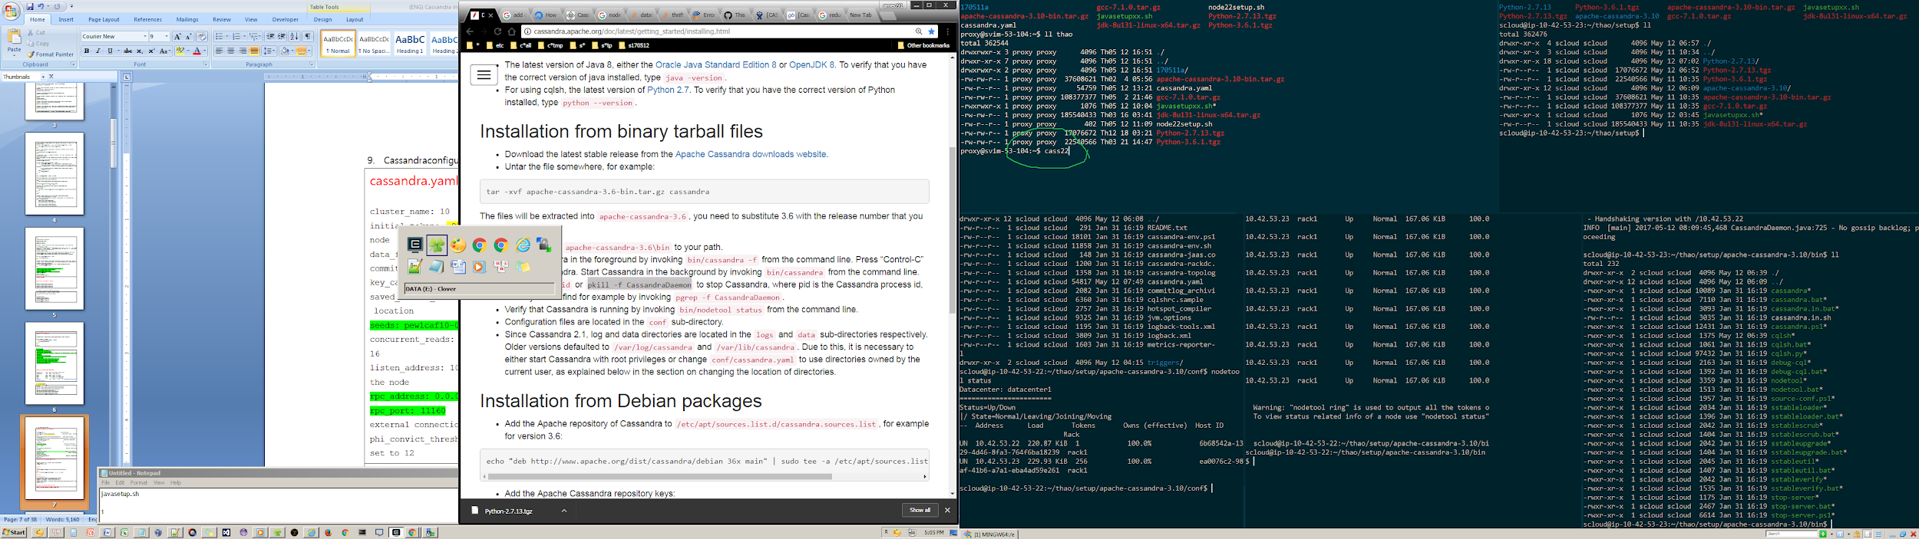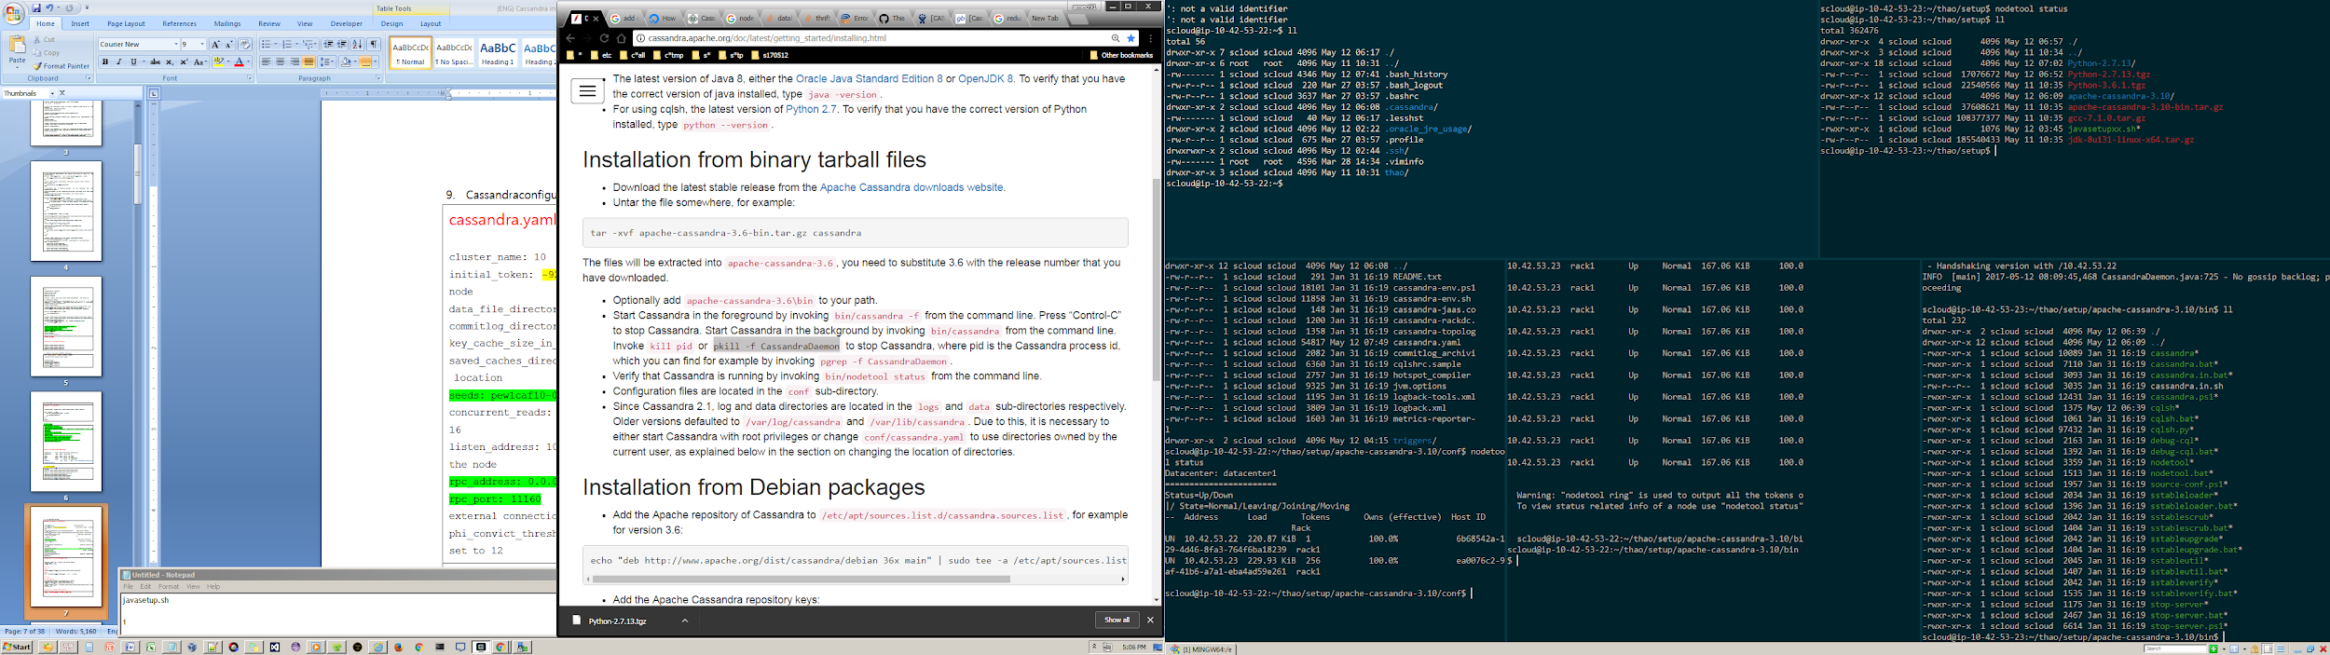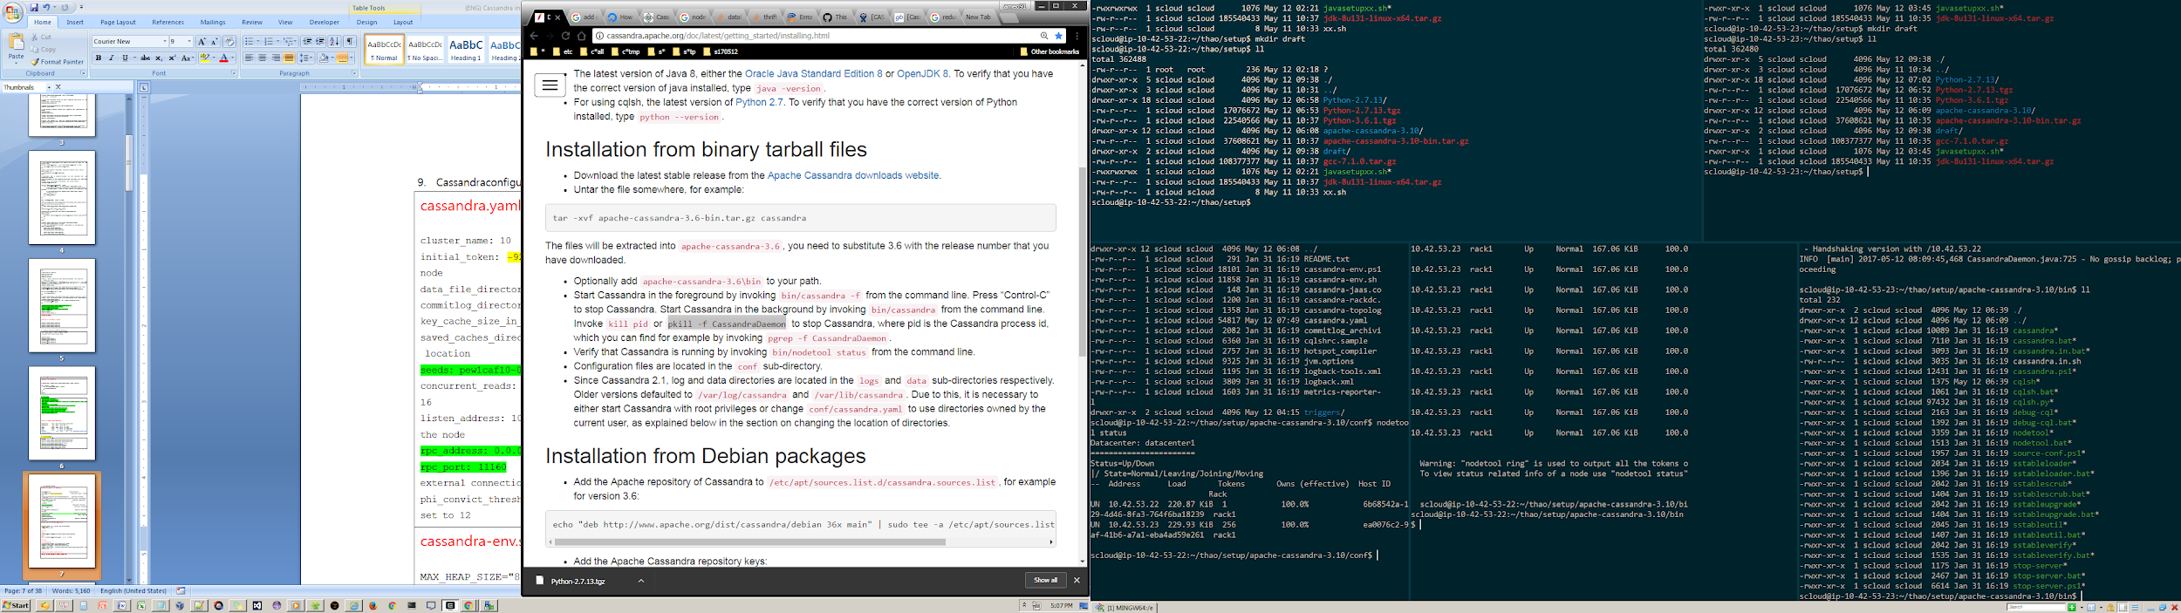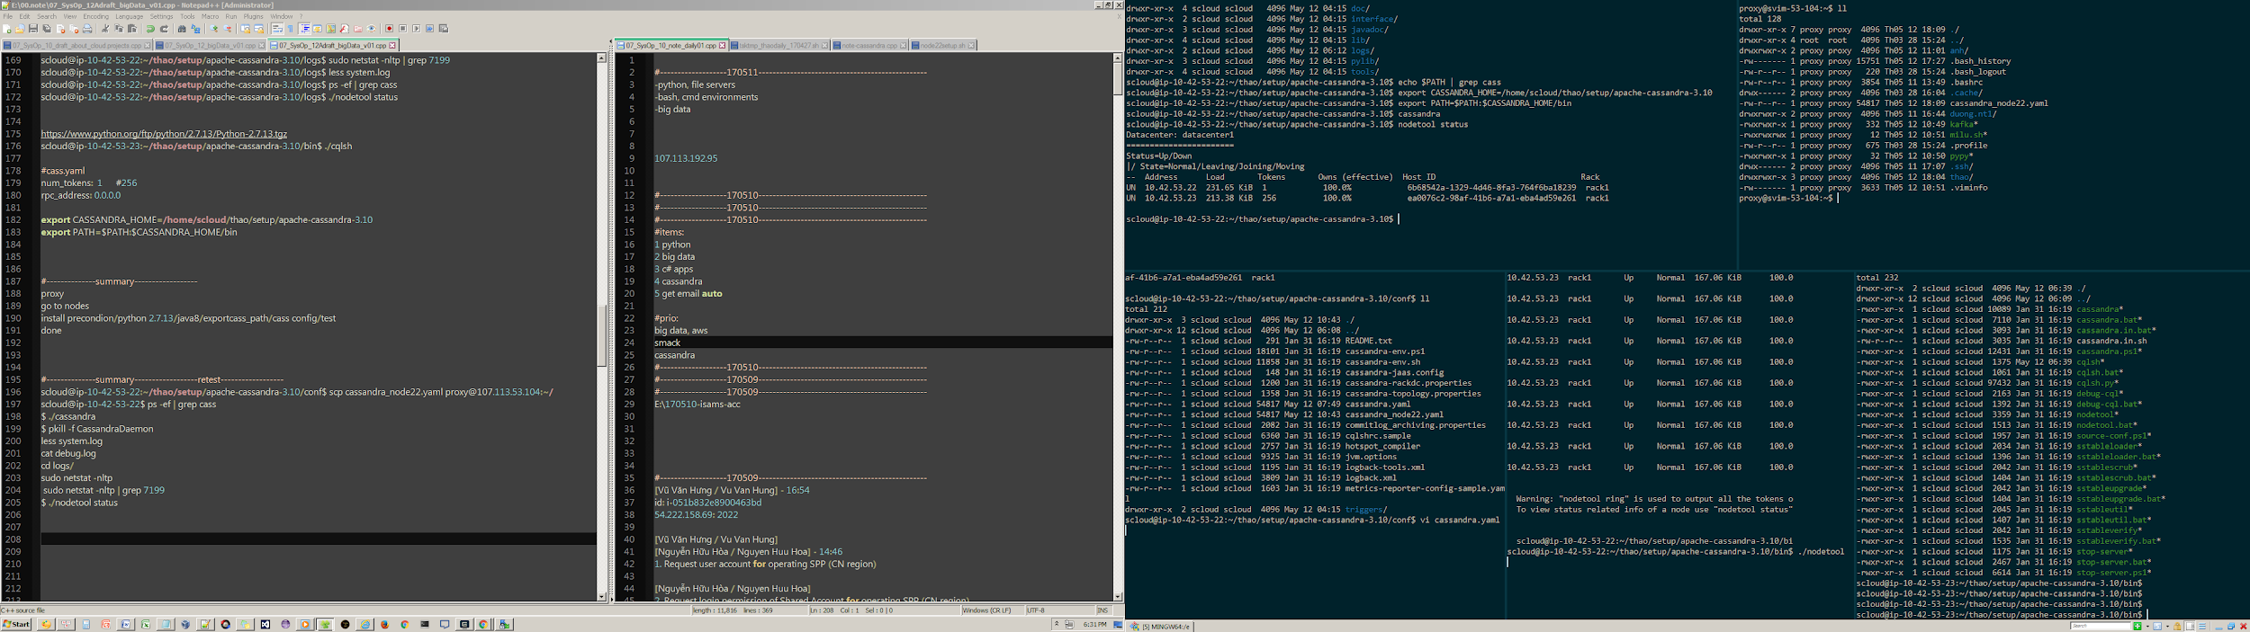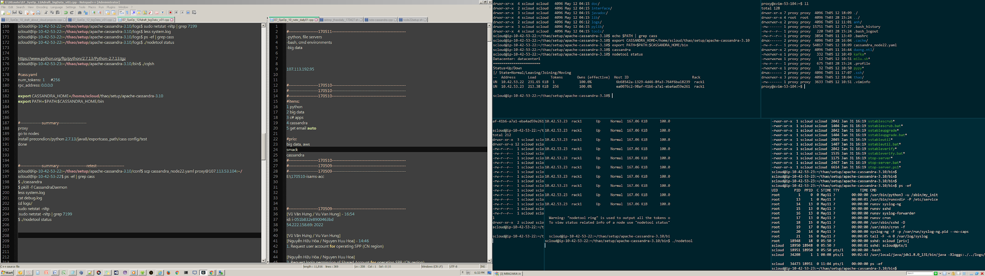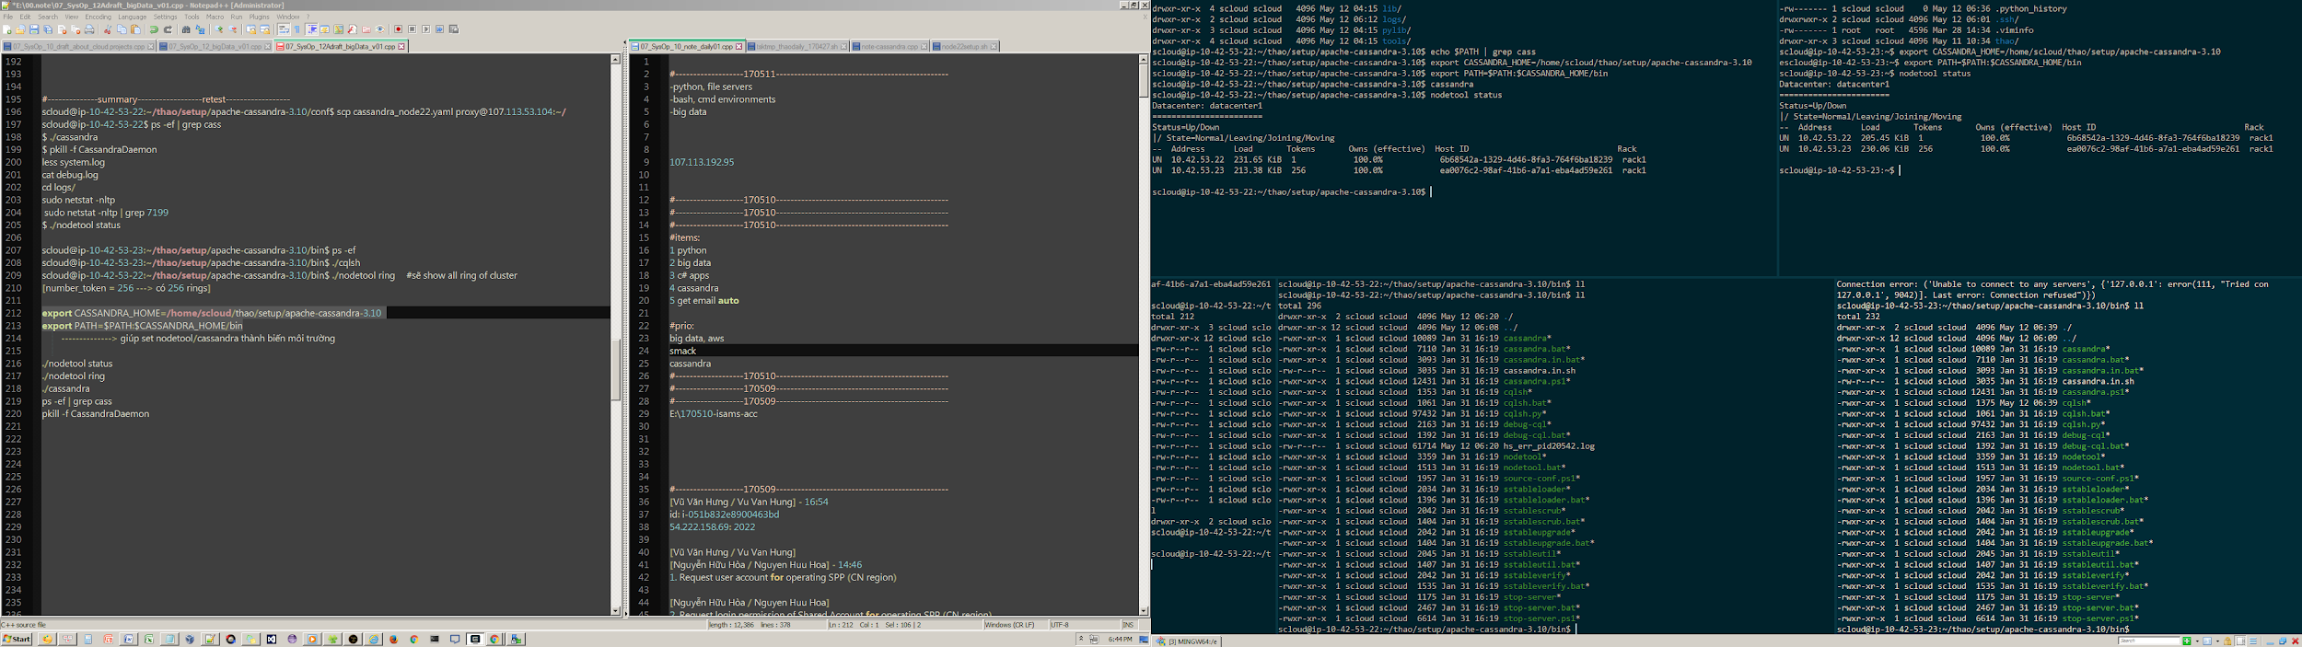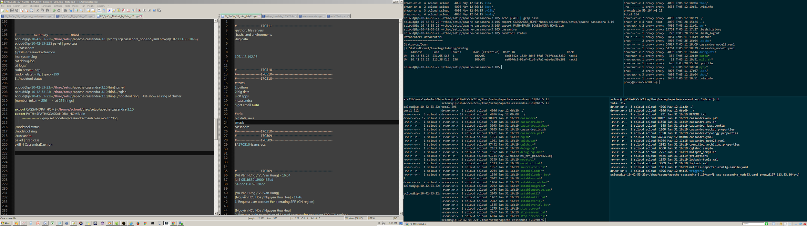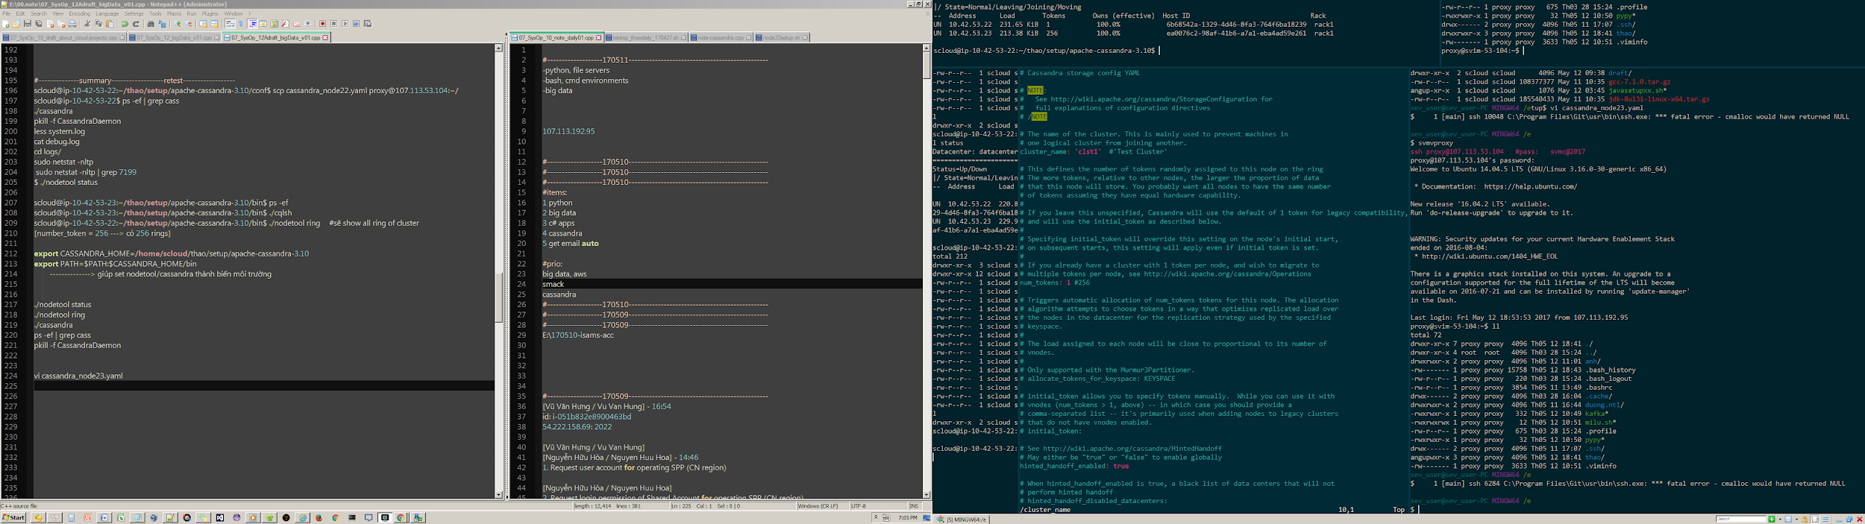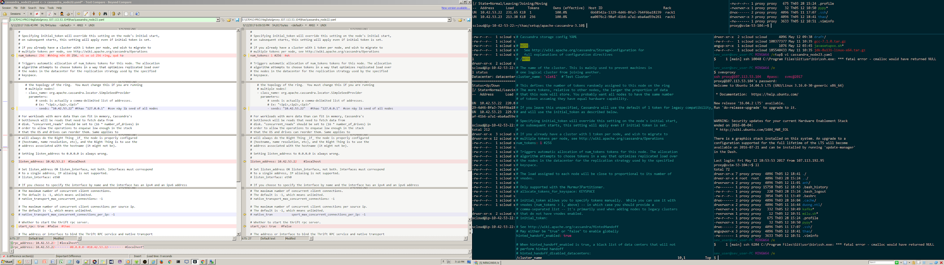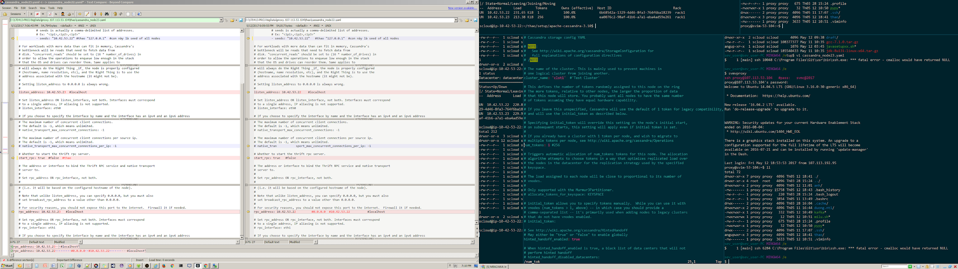

#---------------------------------------------------

#---------------------------------------------------

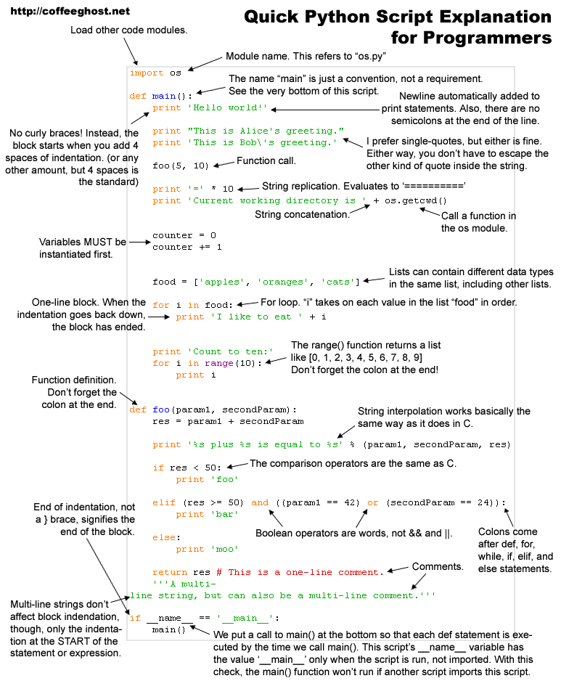

#---------------------------------------------------

#---------------------------------------------------

#---------------------------------------------------

#--------------

#--------------0. Init

function init_instances(){

#run precmd

. /home/scloud/openstack/identity/admin_openrc

#init system

flag_of_SET01=false

logs_of_SET01="/home/scloud/nguyen.tthao/nova-auto-logs/logs_of_SET01.txt"

logs_of_SET02="/home/scloud/nguyen.tthao/nova-auto-logs/logs_of_SET02.txt"

logs_of_SET03="/home/scloud/nguyen.tthao/nova-auto-logs/logs_of_SET03.txt"

logs_of_SET04="/home/scloud/nguyen.tthao/nova-auto-logs/logs_of_SET04.txt"

logs_of_SET05="/home/scloud/nguyen.tthao/nova-auto-logs/logs_of_SET05.txt"

logs_of_SET06="/home/scloud/nguyen.tthao/nova-auto-logs/logs_of_SET06.txt"

#init vars

my_option=0

my_set=0

my_auto=0

my_instance_name="thao_nova_01"

my_instance_ID="empty"

my_flavor="m1.small"

my_image="Ubuntu14.04"

my_security_groups="default"

my_key_name="thaokpair1"

my_net_id="0609b593-3456-4ee2-8373-a90a492e1a48"

my_availability_zone="cinfra-17"

}

function init_instances_set_of_testcases(){

var1="#--------------------nova-function-automation-testing-set-01: \n

#Scenario 1: \n

1. Create 1 instance from images or snapshot or volumes (create keypair (O)) \n

2. Check intance status is running or not \n

3. If instance is running => login to instance with keypair (O) \n

4. Stop instances \n

5. If stop done => terminate instance"

var2="#--------------------nova-function-automation-testing-set-02: \n

#Scenario 2: \n

1. Create instance \n

2. Check instance status \n

3. Set metadata on an instance \n

4. Create an instance snapshot \n

5. Restore from snapshot \n

6. Stop instances (2 instance) \n

7. Terminate instances"

var3="#--------------------nova-function-automation-testing-set-03: \n

#Scenario 3 \n

1. Create instance \n

2. Check instance status \n

3. Pause, suspend, stop, rescue, resize, rebuild, reboot an instance (check each status) \n

4. Terminate instance"

var4="#--------------------nova-function-automation-testing-set-04: \n

#Scenario 4 \n

Run #Scenario 1 concurrently (30mins) #"

var5="#--------------------nova-function-automation-testing-set-05: \n

#Scenario 5 \n

1. create instance \n

2. Check instance status \n

3. Create snapshot => check status => delete snapshot (30mins) \n

4. terminate instance"

var6="#--------------------nova-function-automation-testing-set-06: \n

#Scenario 6 \n

1. Create instance \n

2. Check instance status \n

3. Resize instance (many times) \n

4. Terminate instance"

case $1 in

1)

echo -e $var1;

;;

2)

echo -e $var2;

;;

3)

echo -e $var3;

;;

4)

echo -e $var4;

;;

5)

echo -e $var5;

;;

6)

echo -e $var6;

;;

esac

}

function create_instances(){

echo '##--------------1. Create 1 instance from images or snapshot or volumes (create keypair (O))'

#theem: mages or snapshot or volumes (create keypair (O))

my_instance_ID=$(nova boot $my_instance_name --flavor $my_flavor --image $my_image --security-groups $my_security_groups --key-name $my_key_name --nic net-id=$my_net_id --availability-zone $my_availability_zone | egrep -w 'id' | awk -F'|' '/\|/ && !/ID/{print ""$3""}') #--wait

echo "my_instance_name: "$my_instance_name

echo "my_instance_ID: "$my_instance_ID #getID to use for all cases

sleep 9

}

function create_instances_multi(){

echo '##--------------10. Create multi instance from images or snapshot or volumes (create keypair (O))'

nova boot $my_instance_name --flavor $my_flavor --image $my_image --security-groups $my_security_groups --key-name $my_key_name --nic net-id=$my_net_id --availability-zone $my_availability_zone --min-count 5 #--wait

echo "create_instances_multi: my_instance_name: $my_instance_name"

sleep 9

array=(`nova list | grep $my_instance_name | awk -F'|' '/\|/ && !/Property/{print ""$2" ""$4" and "$6""}'`)

for i in "${array[@]}"; do

echo "creating: $i"

done

}

function check_instances_status(){

echo '##--------------2a. Check intance status'

#check 1: get status

my_options=$4

myInput="empty now..."

myTime=0

while true

do

myInput=$(nova list $my_options | grep $my_instance_ID | awk -F'|' '/\|/ && !/Property/{print ""$4" and "$6""}');

sleep 9

myTime +=9

echo "logs------------------------------01"

echo "my_instance_ID: "$my_instance_ID

echo "expected: $2 and $3"

echo "myInput getted: $myInput"

echo "logs------------------------------02"

case $myInput in

*"ERROR"*)

echo "ERROR: failed myInput: "$myInput

flag_of_SET01=false

return 1;

;;

*"Running"*) # & *"ACTIVE"*

echo "Running: passed myInput: "$myInput

flag_of_SET01=true

return 1;

;;

*"DELETED"*) #stop

echo "DELETED: passed myInput: "$myInput

flag_of_SET01=true

return 1;

;;

*"stop"*) #stop

echo "passed myInput: "$myInput

return 1;

;;

*"pause"*) #stop

echo "passed myInput: "$myInput

return 1;

;;

esac

case $my_options in

*" --status deleted"*) #----chrome

echo "DELETED: passed myInput: "$myInput

return 1;

;;

esac

#escape if timeout

#if [ "$myInput"==$1 ]; then

# echo "failed...status getted myInput: $myInput..."

# flag_of_SET01=false

# return 1;

#fi

done

echo "logs------------------------------03"

flag_of_SET01=true

echo "flag_of_SET01 now: "$flag_of_SET01

}

function get_instances_info(){

echo '##--------------2b. Check intance status get_instances_info'

#check 2: get info

myInput=$(nova show $my_instance_ID | egrep -w 'id|name|key_name|status');

echo "$myInput"

#if [ "$myInput"=="thaokpair1" -a "$myInput"=="$my_instance_ID" ]; then #-a "$myInput"=="ACTIVE"

# flag_of_SET01=true

#fi --> case

}

#echo '##--------------3. If instance is running => login to instance with keypair (O)'

function stop_instances(){

echo '##--------------4. Stop instances'

nova stop $my_instance_ID #--wait

#Task State

#powering-off

}

function terminate_instances(){

echo '##--------------5. If stop done => terminate instance'

nova delete $my_instance_ID #--wait

}

function terminate_instances_multi(){

echo '##--------------5. If stop done => terminate instance'

echo "delete: my_instance_name: $my_instance_name"

array=(`nova list | grep $my_instance_name | awk -F'|' '/\|/ && !/Property/{print ""$2""}'`)

for i in "${array[@]}"; do

echo "delete: $i"

nova delete $i #--wait

done

}

#logging

function flag_of_SET01(){

if [ "$flag_of_SET01"=="false" ]; then #-a "$myInput"=="ACTIVE"

echo "failed SET01"

return 0;

fi

return 1;

}

function print_logs(){

echo "#--------------------log:"

echo "#Scenario 1: create instance $my_instance_name $my_instance_ID: flag_of_SET01: $flag_of_SET01" >> $logs_of_SET01

}

function nova_menu(){

echo "Scenarios of nova:"

init_instances_set_of_testcases 1

init_instances_set_of_testcases 2

init_instances_set_of_testcases 3

init_instances_set_of_testcases 4

init_instances_set_of_testcases 5

init_instances_set_of_testcases 6

echo "#--------------------Please choose a set of testcase as following:

1) set 1

2) set 2

3) set 3

4) set 4

5) set 5

6) set 6

7) set 7

8) set 8

0) exit

x) help"

while [ "$my_set"!=0 ]

do

echo "Please choose a set of testcase..."

read my_set

echo "Please choose a auto(1) or manual(0)..."

read my_auto

case $my_set in

0)

echo "pls see logs after running"

return 1;

;;

1)

init_instances_set_of_testcases 1

nova_menu_set_01 $my_auto

;;

2)

init_instances_set_of_testcases 2

nova_menu_set_02 $my_auto

;;

3)

;;

4)

;;

5)

;;

6)

;;

7)

;;

8)

;;

esac

done

}

function nova_menu_set_01(){

echo "#--------------------Please choose an option following:

1) create_instances

10) create_instances multi

2) get_instances_info

3) stop_instances

4) terminate_instances

5) terminate_instances_multi

6) print_logs

7) play all steps

8) exit"

case $my_auto in

0)

;;

1)

nova_menu_set_01_auto

return 1;

;;

esac

while [ "$my_option"!=0 ]

do

echo "Please choose an option..."

read my_option

case $my_option in

#0)

# echo "pls see logs after running"

#;;

1)

create_instances

check_instances_status "ERROR" "Running" "ACTIVE" ""

get_instances_info

;;

10)

create_instances_multi

check_instances_status "ERROR" "Running" "ACTIVE" ""

get_instances_info

;;

2)

get_instances_info

;;

3)

stop_instances

check_instances_status "ERROR" "Shutdown" "SHUTOFF" ""

;;

4)

#if [ flag_of_SET01 ]; then

terminate_instances

#fi

check_instances_status "ERROR" "Shutdown" "SHUTOFF" " --status deleted"

;;

5)

#if [ flag_of_SET01 ]; then

terminate_instances_multi

#fi

check_instances_status "ERROR" "Shutdown" "SHUTOFF" " --status deleted"

;;

6)

#print_logs

cat $logs_of_SET01

;;

7)

;;

8)

return 1;

;;

esac

done

}

function nova_menu_set_01_auto(){

create_instances

check_instances_status "ERROR" "Running" "ACTIVE" ""

get_instances_info

stop_instances

check_instances_status "ERROR" "Shutdown" "SHUTOFF" ""

#if [ flag_of_SET01 ]; then

terminate_instances_multi

#fi

check_instances_status "ERROR" "Shutdown" "SHUTOFF" " --status deleted"

#print_logs

cat $logs_of_SET01

}

#main

init_instances

nova_menu

#---------------------------------------------------

#---------------------------------------------------

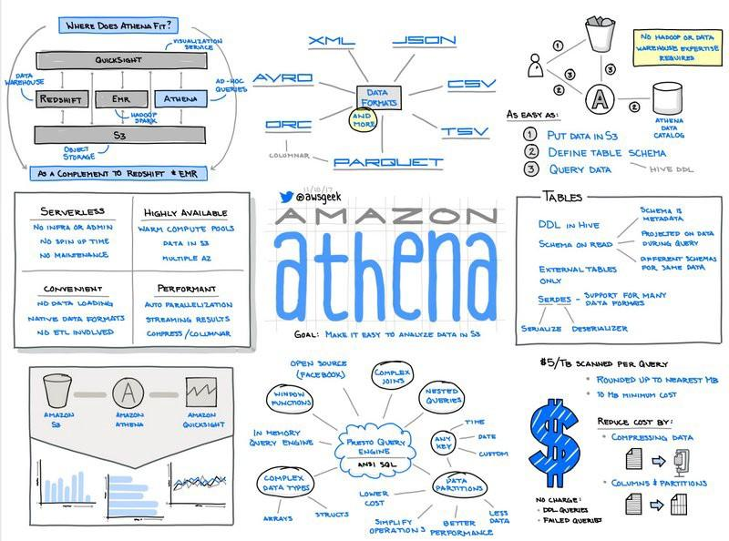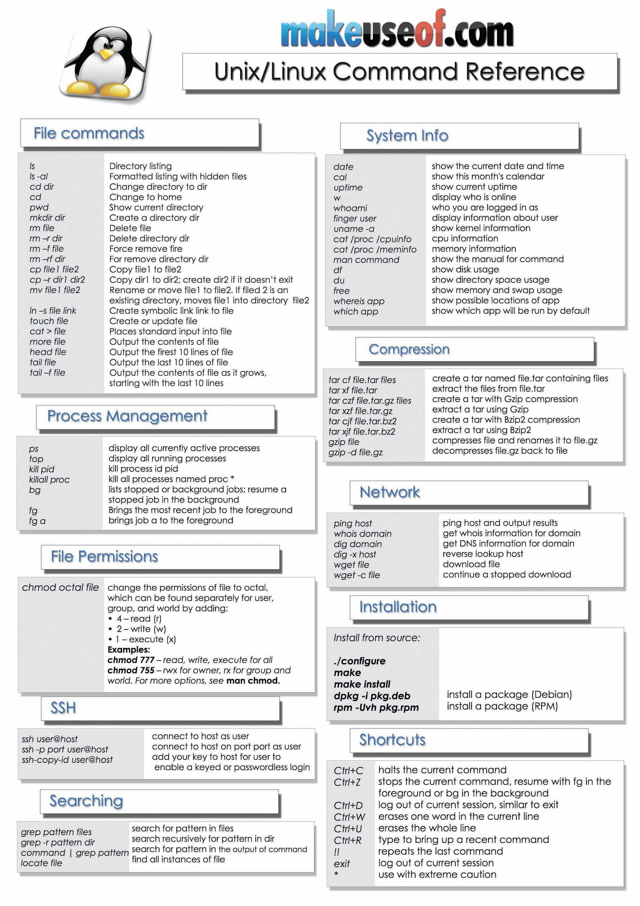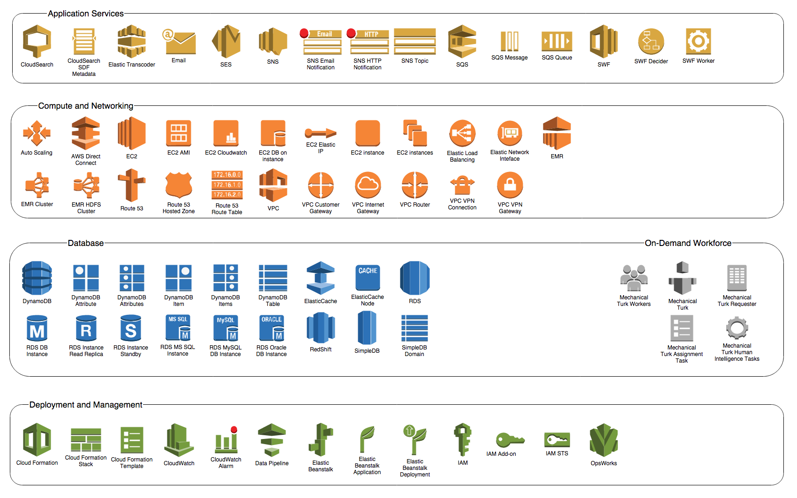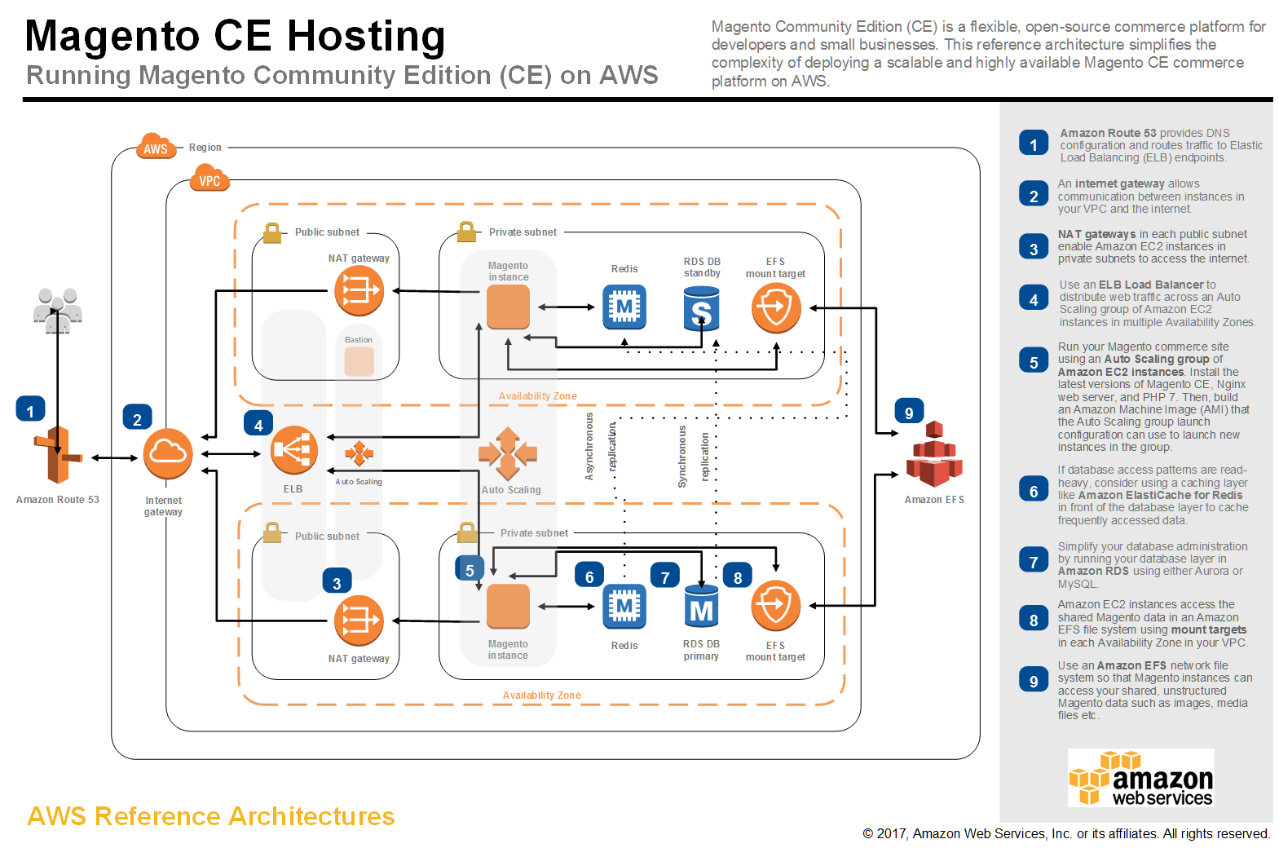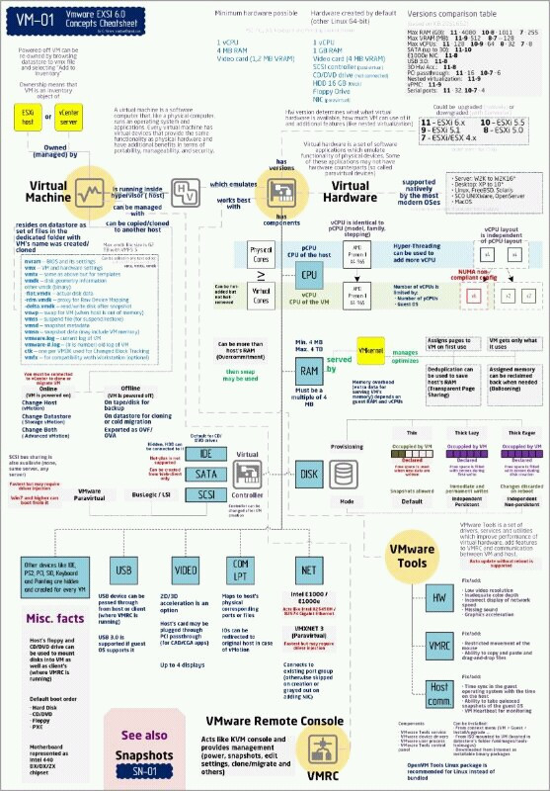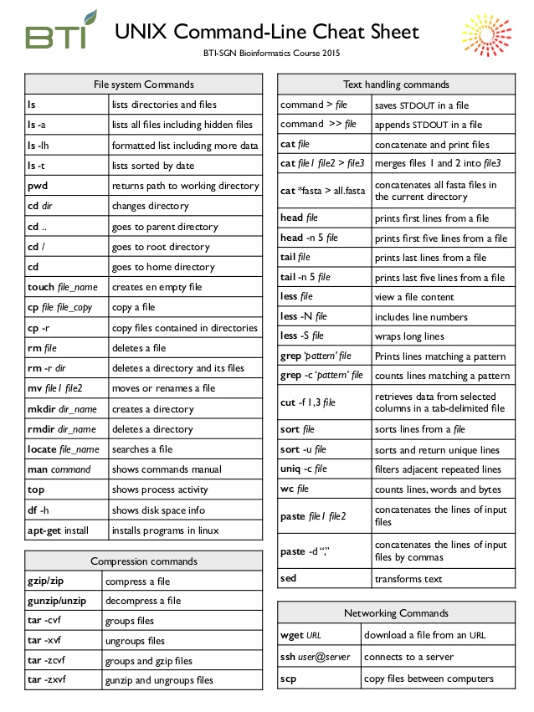

#---------------------------------------------------

#---------------------------------------------------

#---------------------------------------------------

#---------------------------------------------------

AWS Certified Solutions Architect - Associate Level

Exam Blueprint

1

Introduction

The AWS Certified Solutions Architect – Associate Level exam is intended for individuals who perform a Solutions

Architect role. This exam validates an examinee’s ability to:

|  |  |
| --- | --- |
|  | Identify and gather requirements in order to define a solution to be built using architecture best practices  Be capable of providing guidance on architectural best practices to developers and system administrators  throughout the lifecycle of the project |

The knowledge and skills required at this level should include all of the following areas and objective components

below. The knowledge level can be defined as having the majority of following:

AWS Knowledge

|  |  |
| --- | --- |
|  | Hands-on experience using compute, networking, storage, and database AWS services  Professional experience architecting large scale distributed systems  Understanding of Elasticity and Scalability concepts |
|  | Understanding of network technologies as they relate to AWS  A good understanding of all security features and tools that AWS provides and how they relate to  traditional services  A strong understanding on how to interact with AWS (AWS SDK, AWS API, Command Line Interface,  AWS CloudFormation)  Hands-on experience with AWS deployment and management services |
|  |  |
|  |  |

General IT Knowledge

|  |  |
| --- | --- |
|  | Excellent understanding of typical multi-tier architectures: web servers (Apache, nginx, IIS), caching,  application servers, and load balancers  RDBMS (MySQL, Oracle, SQL Server), NoSQL  Knowledge of message queuing and Enterprise Service Bus (ESB)  Familiarity with loose coupling and stateless systems  Understanding of different consistency models in distributed systems  Experience with CDN, and performance concepts  Network experience with route tables, access control lists, firewalls, NAT, HTTP, DNS, IP and OSI  Network  Knowledge of RESTful Web Services, XML, JSON  Familiarity with the software development lifecycle  Work experience with information and application security including public key encryption, SSH, access  credentials, and X.509 certificates |
|  |  |
|  |  |

These training courses or other equivalent methodologies will assist in exam preparation:

|  |  |
| --- | --- |
|  | Architecting on AWS (aws.amazon.com/training/architect)  In-depth knowledge or training in at least one high-level programming language  AWS Cloud Computing Whitepapers (aws.amazon.com/whitepapers) |

o Overview of Amazon Web Services

o Overview of Security Processes

o AWS Risk & Compliance Whitepaper

o Storage Options in the Cloud

o Architecting for the AWS Cloud: Best Practices

Experience deploying hybrid systems with on-premise and AWS components

Utilization of the AWS Architecture Center website (aws.amazon.com/architecture)

Note: This examination blueprint includes weighting, test objectives, and example content. Example topics and

concepts are included to clarify the test objectives; they should not be construed as a comprehensive listing of all

of the content of this examination.

AWS Certified Solutions Architect - Associate Level

Exam Blueprint

2

The table below lists the domains measured by this examination and the extent to which they are represented.

|  |  |
| --- | --- |
| Domain | % of Examination |
| 1.0 Designing highly available, cost efficient, fault tolerant, scalable systems | 60% |
| 2.0 Implementation/Deployment | 10% |
| 3.0 Data Security | 20% |
| 4.0 Troubleshooting | 10% |
| TOTAL | 100% |

Response Limits

The examinee selects from four (4) or more response options the option(s) that best completes the statement or

answers the question. Distracters or wrong answers are response options that examinees with incomplete

knowledge or skill would likely choose, but are generally plausible responses fitting into the content area defined

by the test objective.

Test item formats used in this examination are:

|  |  |
| --- | --- |
|  | Multiple-choice: examinee selects one option that best answers the question or completes a statement.  The option can be embedded in a graphic where the examinee “points and clicks” on their selection  choice to complete the test item.  Multiple-response: examinee selects more than one option that best answers the question or completes  a statement.  Sample Directions: Read the statement or question and from the response options, select only the |
|  |  |
|  |  |

option(s) that represent the most correct or best answer(s) given the information.

Content Limits

1 Domain 1.0: Designing highly available, cost efficient, fault tolerant, scalable systems

1.1 Identify and recognize cloud architecture considerations, such as fundamental components and effective

designs.

Content may include the following:

How to design cloud services

Planning and design

Monitoring

Familiarity with:

Best practices

Developing to Client Specifications including pricing/cost (e.g., on Demand vs. Reserved vs. Spot,

RTO and RPO DR Design)

Architectural trade-off decisions (high availability vs. cost, Amazon Relational Database Service

(RDS) vs. installing your own database on Amazon Elastic Compute Cloud (EC2))

Integrating with existing development environments and building scalable architecture

Elasticity and scalability

2 Domain 2.0: Implementation/Deployment

2.1 Identify the appropriate techniques and methods using Amazon EC2, Amazon S3, Elastic Beanstalk,

CloudFormation, Amazon Virtual Private Cloud (VPC), and AWS Identity and Access Management (IAM)

to code and implement a cloud solution.

Content may include the following:

Configure an Amazon Machine Image (AMI)

Operate and extend service management in the private cloud

Configure compliance in the private and public cloud

Launching instances in a variety of geographical regions

AWS Certified Solutions Architect - Associate Level

Exam Blueprint

3

3 Domain 3.0: Data Security

3.1 Recognize and implement secure procedures for optimum cloud deployment and maintenance.

Content may include the following:

Cloud Security Best Practices

o How to build and use a threat model

o How to build and use a data flow diagram for risk management

Use cases

Abuse Cases (Negative use cases)

Security Architecture with AWS

o Shared Security Responsibility Model

o AWS Platform Compliance

o AWS security attributes (customer workloads down to physical layer)

o Security Services

o AWS Identity and Access Management (IAM)

o Amazon Virtual Private Cloud (VPC)

o CIA and AAA models, ingress vs. egress filtering, and which AWS services and features

fit

o “Core” Amazon EC2 and S3 security feature sets

o Incorporating common conventional security products (Firewall, IDS:HIDS/NIDS, SIEM,

VPN)

o Design Patterns

o DDOS mitigation

o Encryption solutions

o Complex access controls (building sophisticated security groups, ACLs, etc.)

o Amazon CloudWatch for the security architect

3.2 Recognize critical disaster recovery techniques and their implementation.

Content may include the following:

Disaster Recovery

o Recovery time objective

o Recovery point objective

o Amazon Elastic Block Store

AWS Import/Export

AWS Storage Gateway

Amazon Route53

Testing the recovered data

4 Domain 4.0: Troubleshooting

Content may include the following:

General troubleshooting information and questions

#---------------------------------------------------

#---------------------------------------------------

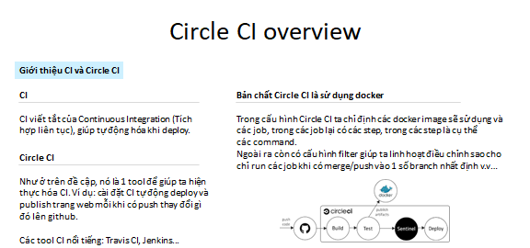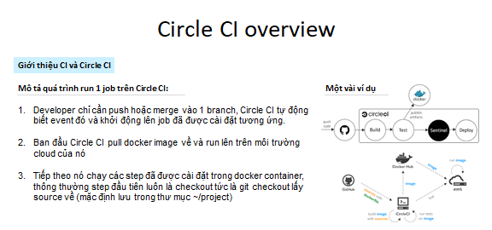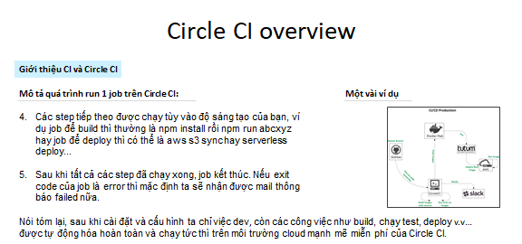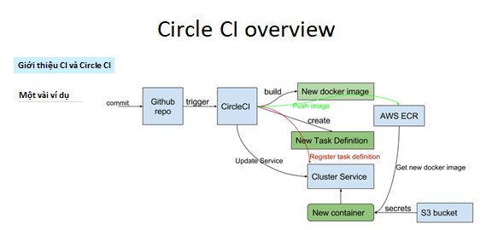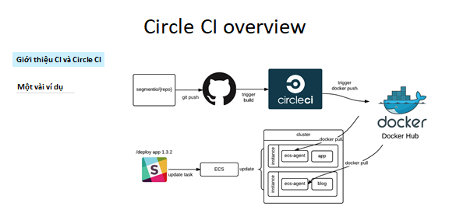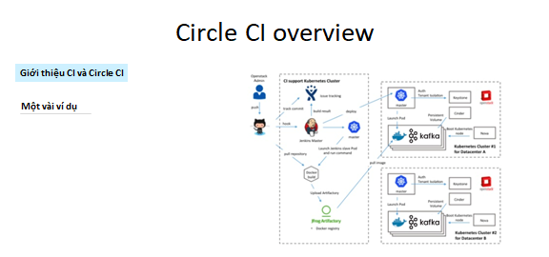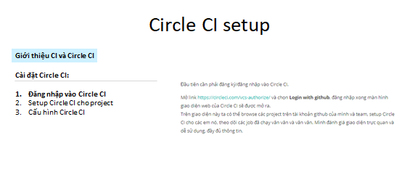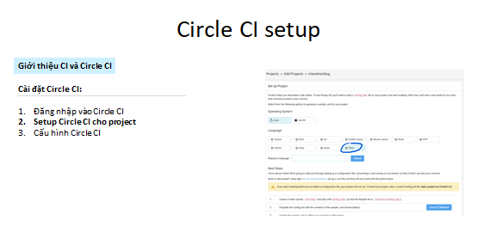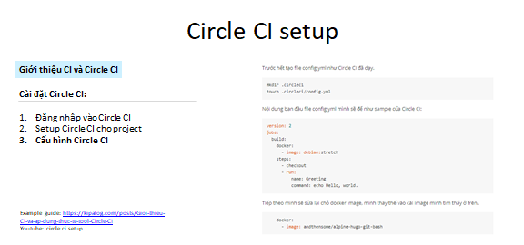

Comparision and review

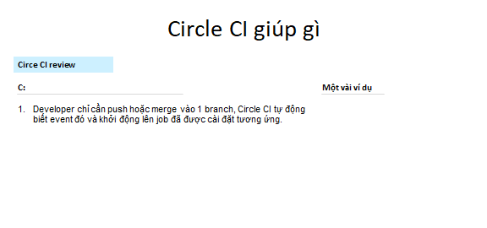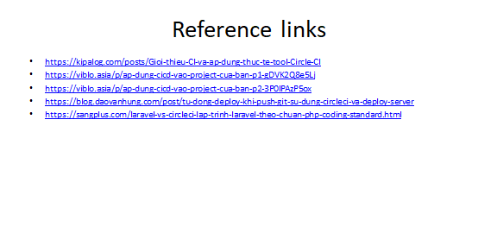

Demo



#---------------------------------------------------

#---------------------------------------------------

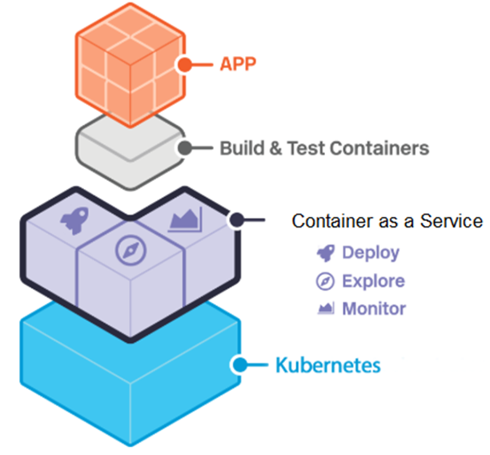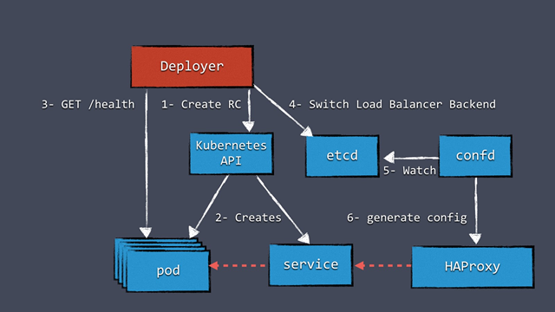

#---------------------------------------------------

Networking_cheatsheet.pdf

**Apache Ignite: Why we should try to use it ?**

#---------------------------------------------------



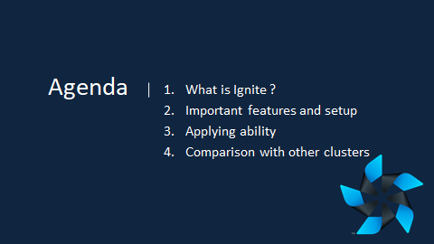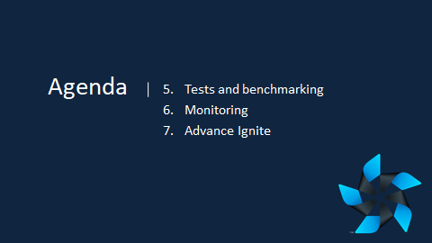

1. What is Ignite ?

2. Why is Ignite ?

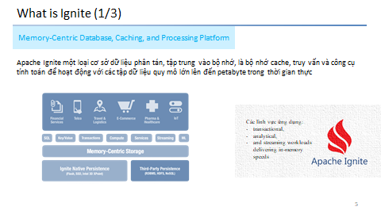

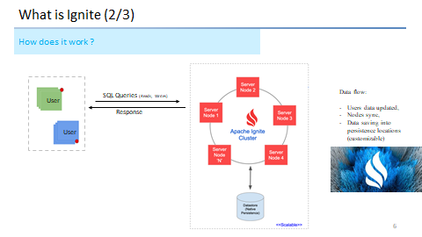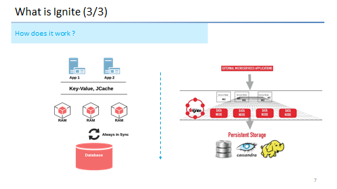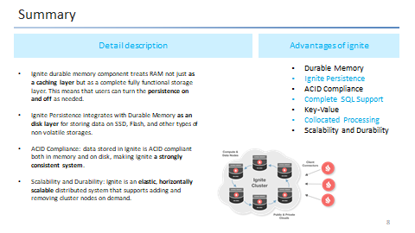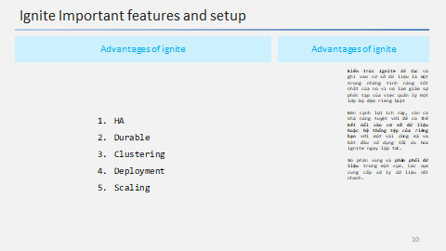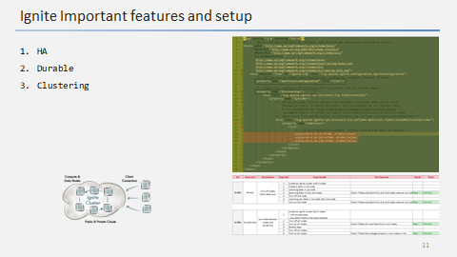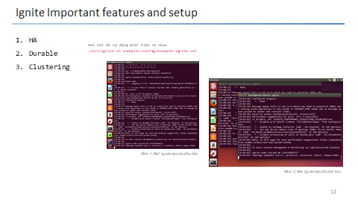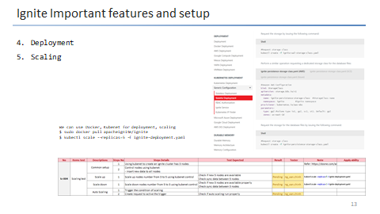

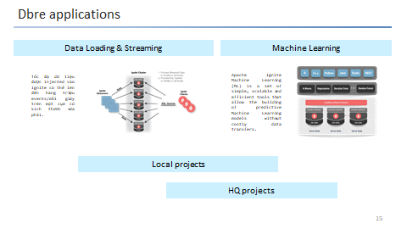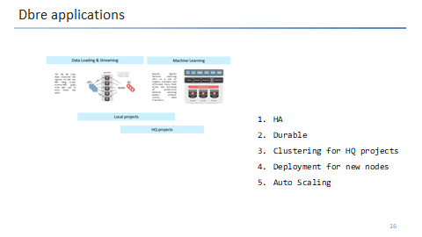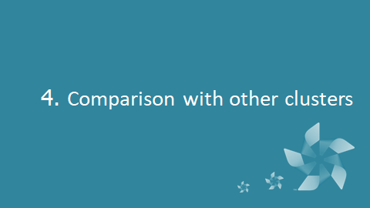

Redis comparision

5. Tests and benchmarking

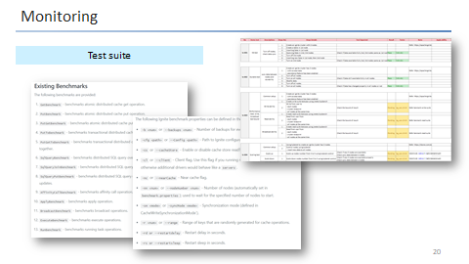

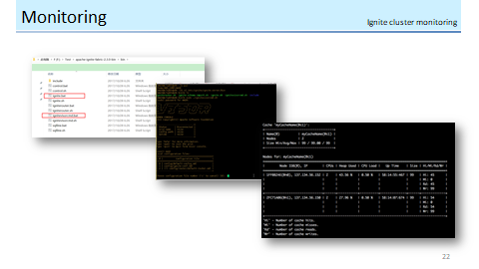

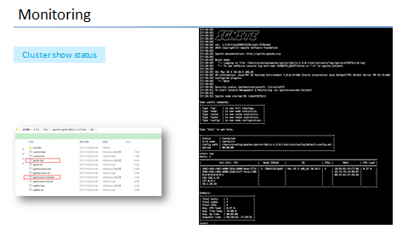

•https://apacheignite.readme.io/docs/what-is-ignite